|  |  |  |  |
| --- | --- | --- | --- |
| **No** | **Titleof the Experiment** | **Tools andTechniques** | **Expected Skill/Ability** |
| 1 | The height(in cm) of a group of fathers and sons are given below,Find the lines of regression and estimate the height of son when the height of father is 164 cm.   |  |  |  |  |  |  |  |  |  |  |  | | --- | --- | --- | --- | --- | --- | --- | --- | --- | --- | --- | | Plot the graph.Hgt of Fathers | 158 | 166 | 163 | 165 | 167 | 170 | 167 | 172 | 177 | 181 | | Hgt of Sons | 163 | 158 | 167 | 170 | 160 | 180 | 170 | 175 | 172 | 175 | | MS Excel | Create and perform operations on Excel data set by applying Linear regression |
| 2 | Using the data file [DISPOSABLE INCOME AND VEHICLE SALES](https://wps.prenhall.com/wps/media/objects/973/997180/dataset_questions/disposable_income.xls), perform the following:   1. Plot a scatter diagram. 2. Determine the regression equation. 3. Plot the regression line (hint: use MS Excel's Add Trendline feature). 4. Compute the predicted vehicle sales for disposable income of $16,500 and of $17,900. 5. Compute the coefficient of determination and the coefficient of correlation | MS Excel | Perform prediction and visualization of data |
| 3 | Managers model costs in order to make predictions. The cost data in the data file [INDIRECT COSTS AND MACHINE HOURS](https://wps.prenhall.com/wps/media/objects/973/997180/dataset_questions/indirect_costs_machine_hours.xls) show the indirect manufacturing costs of an ice-skate manufacturer. Indirect manufacturing costs include maintenance costs and setup costs. Indirect manufacturing costs depend on the number of hours the machines are used, called machine hours. Based on the data for January to December, perform the following operations.   1. Plot a scatter diagram. 2. Determine the regression equation. 3. Plot the regression line (hint: use MS Excel's Add Trendline feature). 4. Compute the predicted indirect manufacturing costs for 300 machine hours and for 430 machine hours. 5. Compute the coefficient of determination and the coefficient of correlation 6. Compute the coefficient of determination and the coefficient of correlation. | MS Excel | Perform prediction and visualization of data |
| 4 | Apply multiple linear regression to predict the stock index price which is a dependent variable of a fictitious economy based on two independent / input variablesinterest rateand unemployment rate.   |  |  |  |  |  | | --- | --- | --- | --- | --- | | year | month | interest rate | unemployment rate | stock index price | | 2020 | 10 | 2.75 | 5.3 | 1464 | | MS Excel | Perform prediction and visualization of data |
| 5. | Calculate the total interest paid on a car loan which has been availed from HDFC bank. For example, Rs.10,00,000 has been borrowed from a bank with annual interest rate of 5.2% and the customer needs to pay every month as shown in table below. Calculate the total interest rate paid for a loan availed of Rs.10,00,000during 3 years.   |  |  |  | | --- | --- | --- | | Sl No. | A | B | | 1 | Principal | Rs.10,00,000 | | 2 | Annual interest rate | 5.20% | | 3 | Year of the loan | 3 | | 4 | Starting payment number | 1 | | 5 | Ending payment number | 36 | | 6 | total interest paid during period | ? | | MS Excel | Create Excel data and perform EMI estimator |
| 6 | Create a supplier database of 10 records with SUPPLIER_ID as primary key, SUPPLIER_NAME, PRODUCTS, QUANTITY, ADDRESS, CITY,PHONE_NO and PINCODE, Where SUPPLIER_NAME, PRODUCTS, QUANTITY and PHONE_NO, should not be NULL. | SQL | Creating Tables |
| 7 | Create the customer database of a big Market withCUSTOMER_IDas primary key,CUSTOMER_NAME, PHONE_NO, EMAIL_ID, ADDRESS, CITY and PIN_CODE.Store at least twenty customers details where CUSTOMER_NAME and PHONE_NO are mandatory and display the customer data in alphabetical order. | SQL | Creating and retrieving Tables |
| 8 | Apply linear regression to find the weather (temperature) of a city with the amount of rain in centimeters. Create your own database with following details.   |  |  |  | | --- | --- | --- | | CITY | Temperature in Centigrade | Rain in Centimeters | |  |  |  | | MS Excel | Apply Linear regression |
| 9 | Use the linear regression technique to compare the age of humans with the amount of sleep in hours.   |  |  |  | | --- | --- | --- | | Name | Age in Years | Sleep in hours |   Create your own database with above details. | MS Excel | Apply Linear regression |
| 10 | Apply the linear regression, compare the average salaries of batsman depending on the run rate scored/ recorded in the matches.Assume your own database. | MS Excel | Apply Linear regression |
| 11 | Design the ER diagram and create schema of the REVA library management system. | Entity Relationship | Entity Relationship diagrams |
| 12 | Design the ER diagram and create schema for Hospital Management system. | Entity Relationship | Schema design |

## What is Microsoft Excel?

Microsoft Excel is a spreadsheet program that is used to record and analyse numerical data. Think of a spreadsheet as a collection of columns and rows that form a table. Alphabetical letters are usually assigned to columns and numbers are usually assigned to rows. The point where a column and a row meet is called a cell. The address of a cell is given by the letter representing the column and the number representing a row.

## How to Open Microsoft Excel?

Running Excel is not different from running any other Windows program. If you are running Windows with a GUI like (Windows XP, Vista, and 7) follow the following steps.

* Click on start menu
* Point to all programs
* Point to Microsoft Excel
* Click on Microsoft Excel

**Follow the following steps to run Excel on Windows 8.1**

* Click on start menu
* Search for Excel N.B. even before you even typing, all programs starting with what you have typed will be listed.
* Click on Microsoft Excel

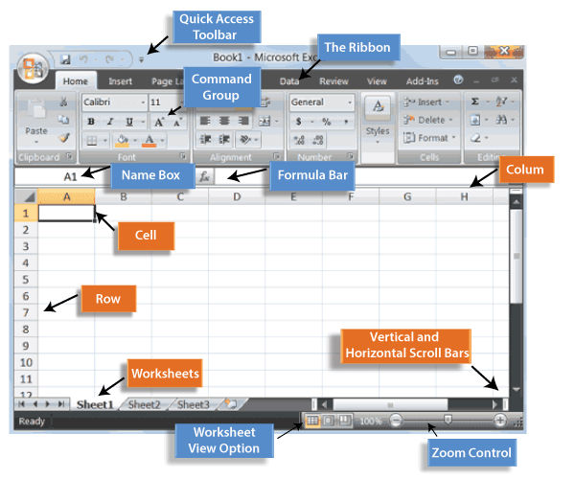

Lab setup to be done before starting the execution of lab programs

**ADDING-IN THE  DATA ANALYSIS TOOLPACK TO EXCEL**

Statistical analysis such as descriptive statistics and regression requires the Excel Data Analysis add-in.  
The default configuration of Excel **does not** automatically support descriptive statistics and regression analysis.   
**You may need to add these** to your computer (a once-only operation).

**Excel 2007**: The Data Analysis add-in should appear at right-end of Data menu as Data Analysis.  
If not then

1. Click the **Microsoft Office Button** , and then click **Excel Options**.

Click on Microsoft office button

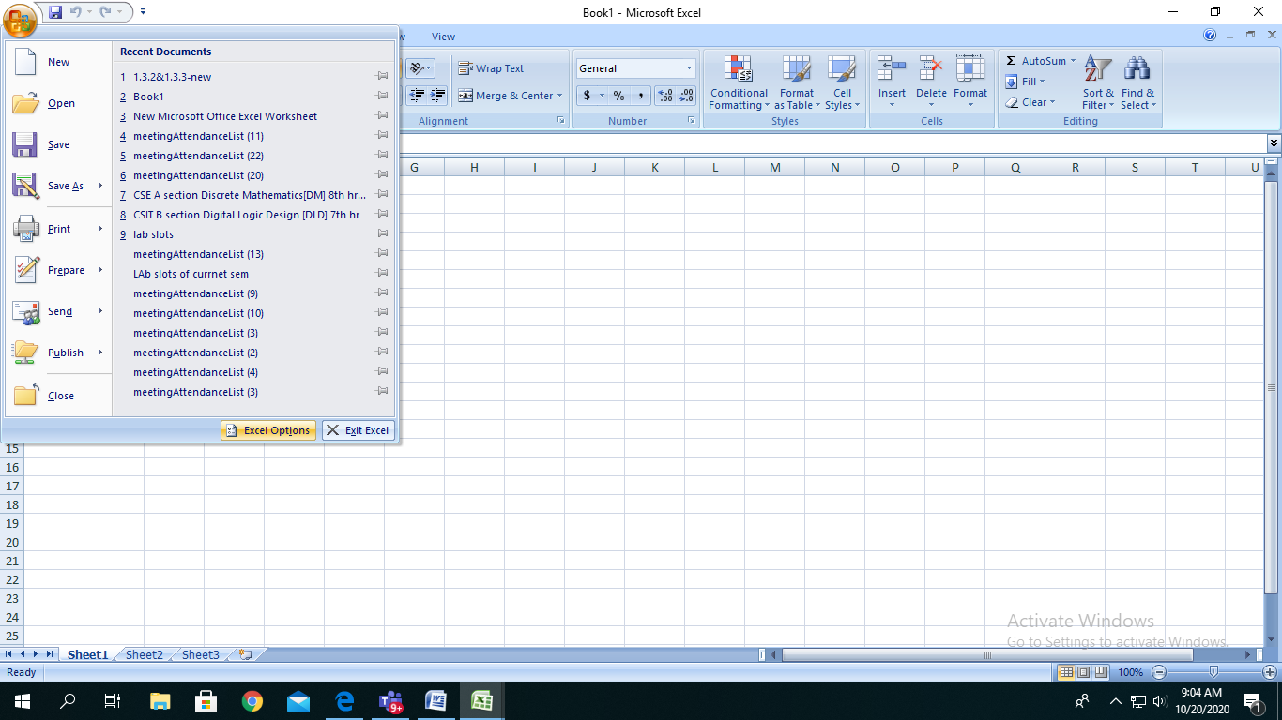

2. Click **Add-Ins**, and then in the **Manage** box, select **Excel Add-ins**.

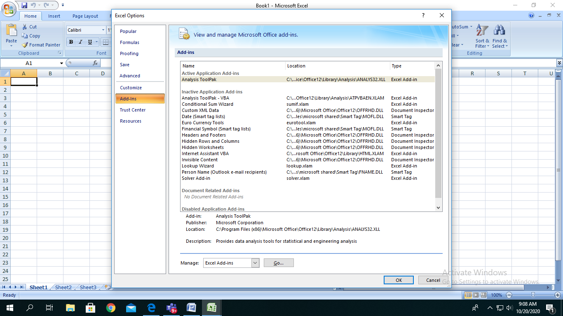

Click on Add on menu

Click on Analysis tool pack

1. Click **Go**.
2. In the **Add-Ins available** box, select the **Analysis ToolPak** check box, and then click **OK**.  
   **Tip**  If **Analysis ToolPak** is not listed in the **Add-Ins available** box, click **Browse** to locate it.  
   If you get prompted that the Analysis ToolPak is not currently installed on your computer, 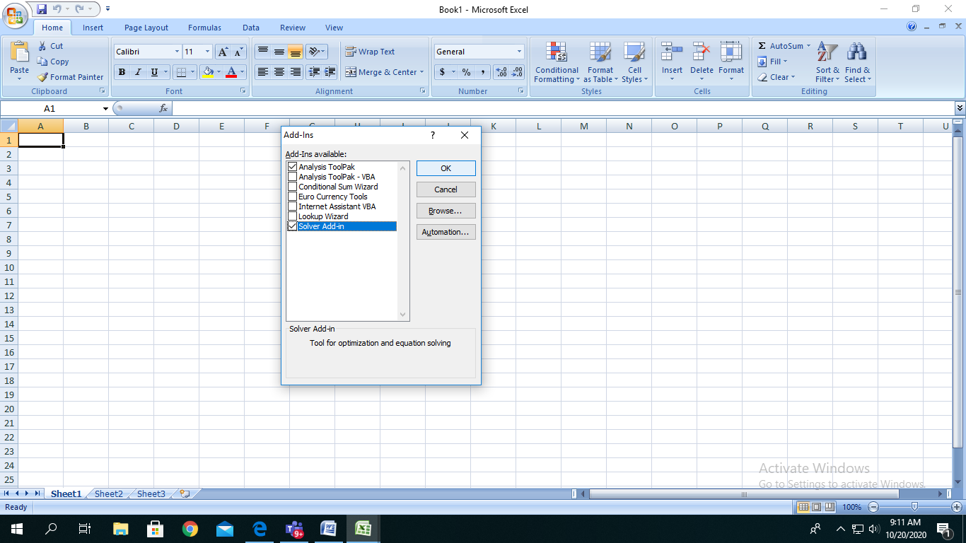 click **Yes** to install it.

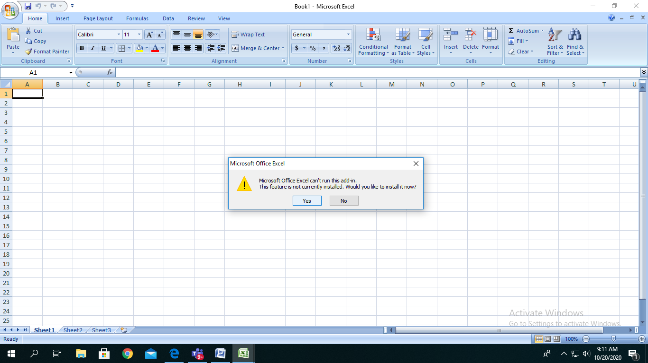

1. After you load the Analysis ToolPak, the **Data Analysis** command is available in the **Analysis** group on the **Data** tab.

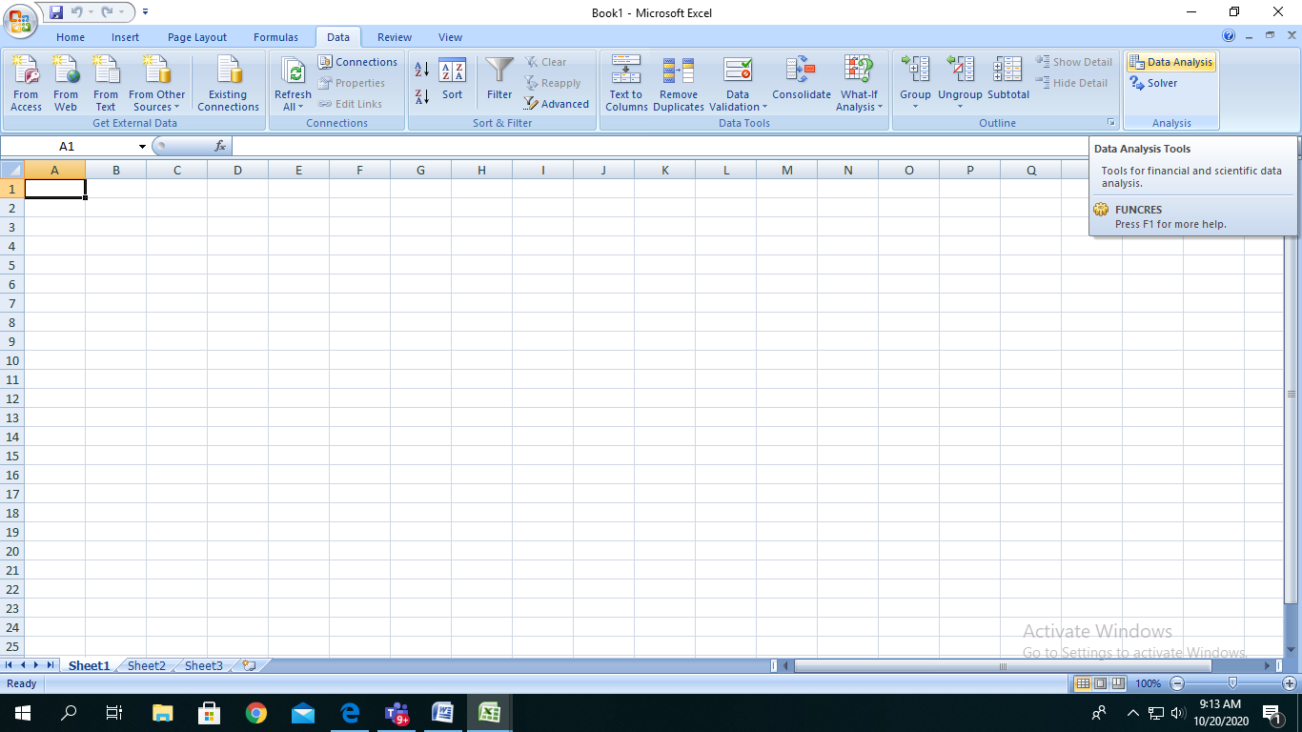

In Data Menu - Data Analysis button will be displayed as shown

This is one time procedure to be followed to add on the Data Analysis button to the Excel. After this procedure is done.

1. The height(in cm) of a group of fathers and sons are given below,Find the lines of regression and estimate the height of son when the height of father is 164 cm.

|  |  |  |  |  |  |  |  |  |  |  |
| --- | --- | --- | --- | --- | --- | --- | --- | --- | --- | --- |
| Plot the graph.Hgt of Fathers | 158 | 166 | 163 | 165 | 167 | 170 | 167 | 172 | 177 | 181 |
| Hgt of Sons | 163 | 158 | 167 | 170 | 160 | 180 | 170 | 175 | 172 | 175 |

Solution:

Step 1: Height data have been taken from dataset.

|  |  |
| --- | --- |
| Hgt of Fathers | Hgt of Sons |
| 158 | 163 |
| 166 | 158 |
| 163 | 167 |
| 165 | 170 |
| 167 | 160 |
| 170 | 180 |
| 167 | 170 |
| 172 | 175 |
| 177 | 172 |
| 181 | 175 |

Step 2: Enter the data for Independent Variable x and dependent variable y as shown above 11 values

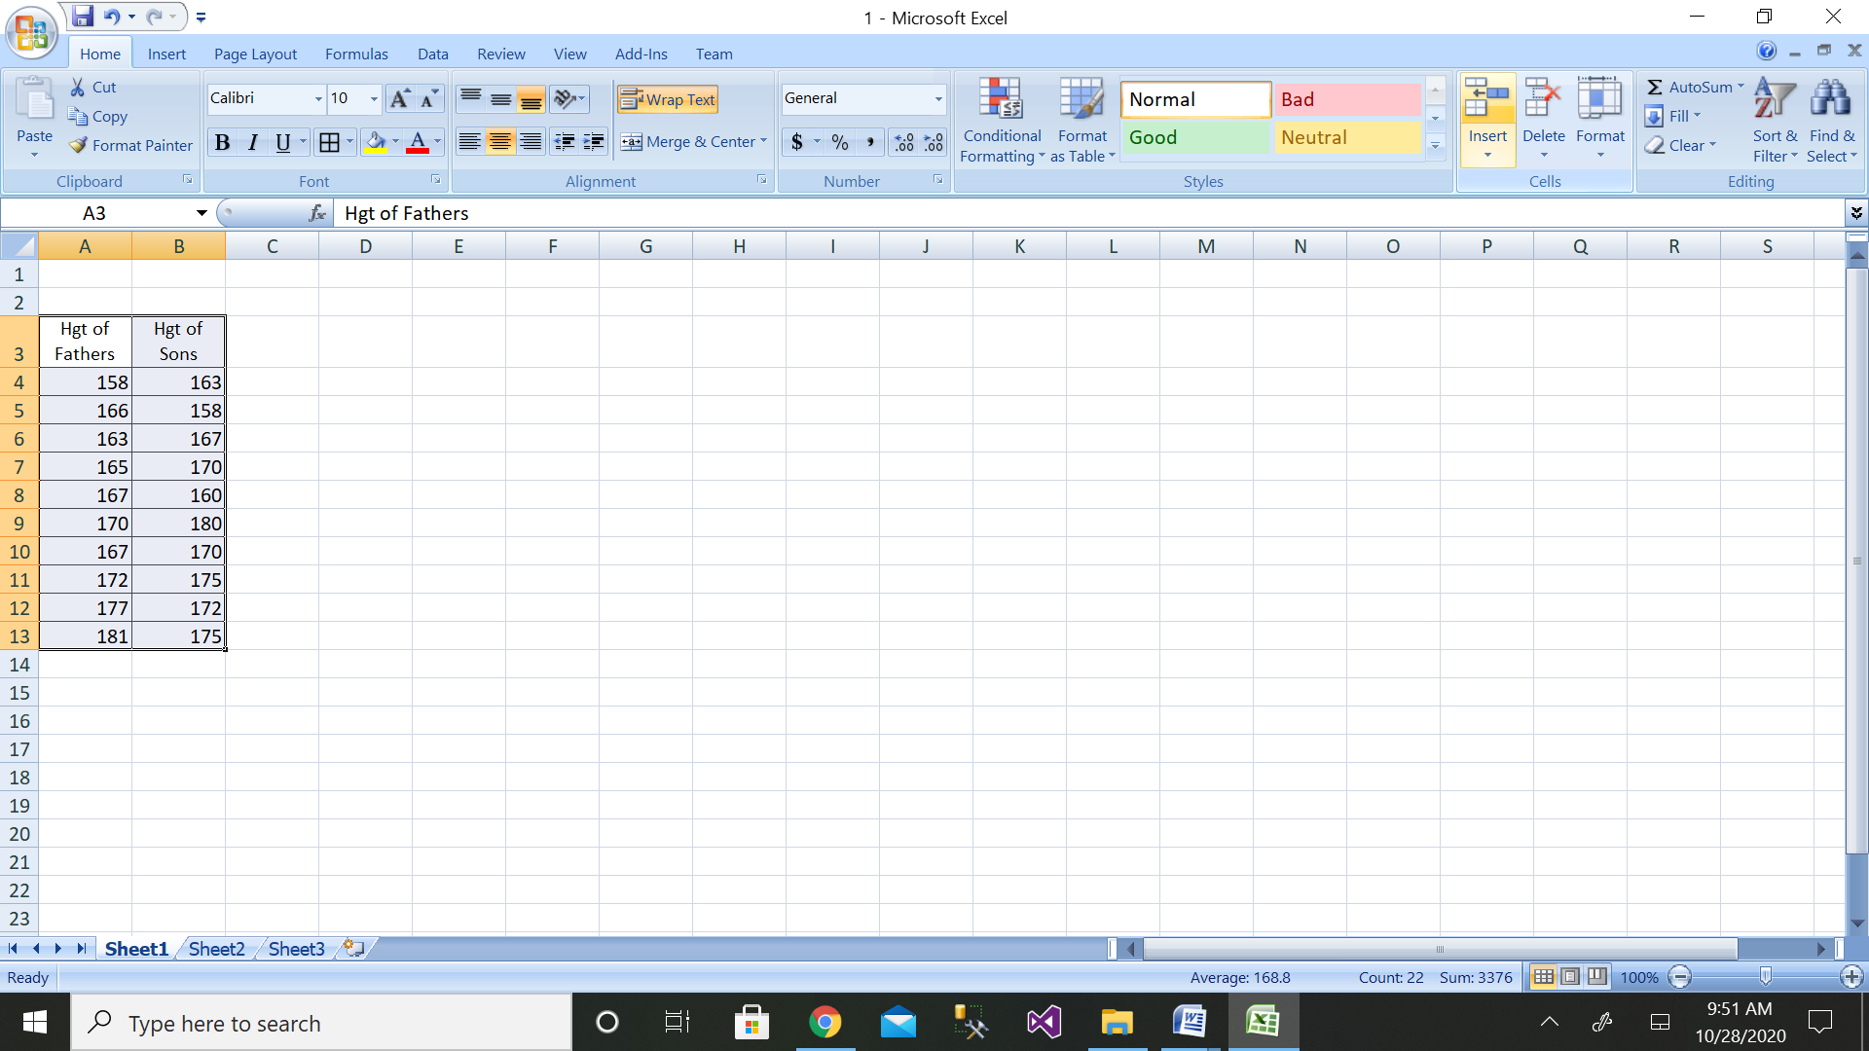

Step 3: Then click on the Data Analysis button

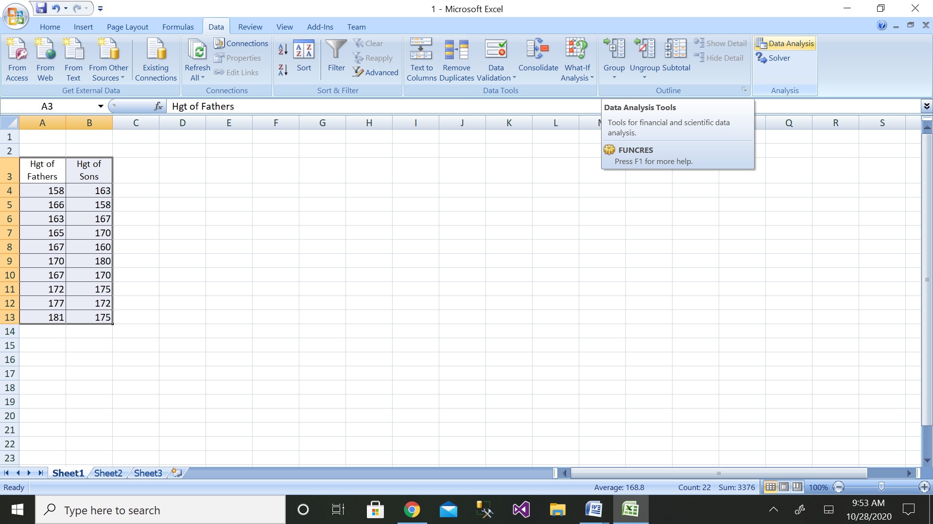

Step 4: Then click on the Regression button

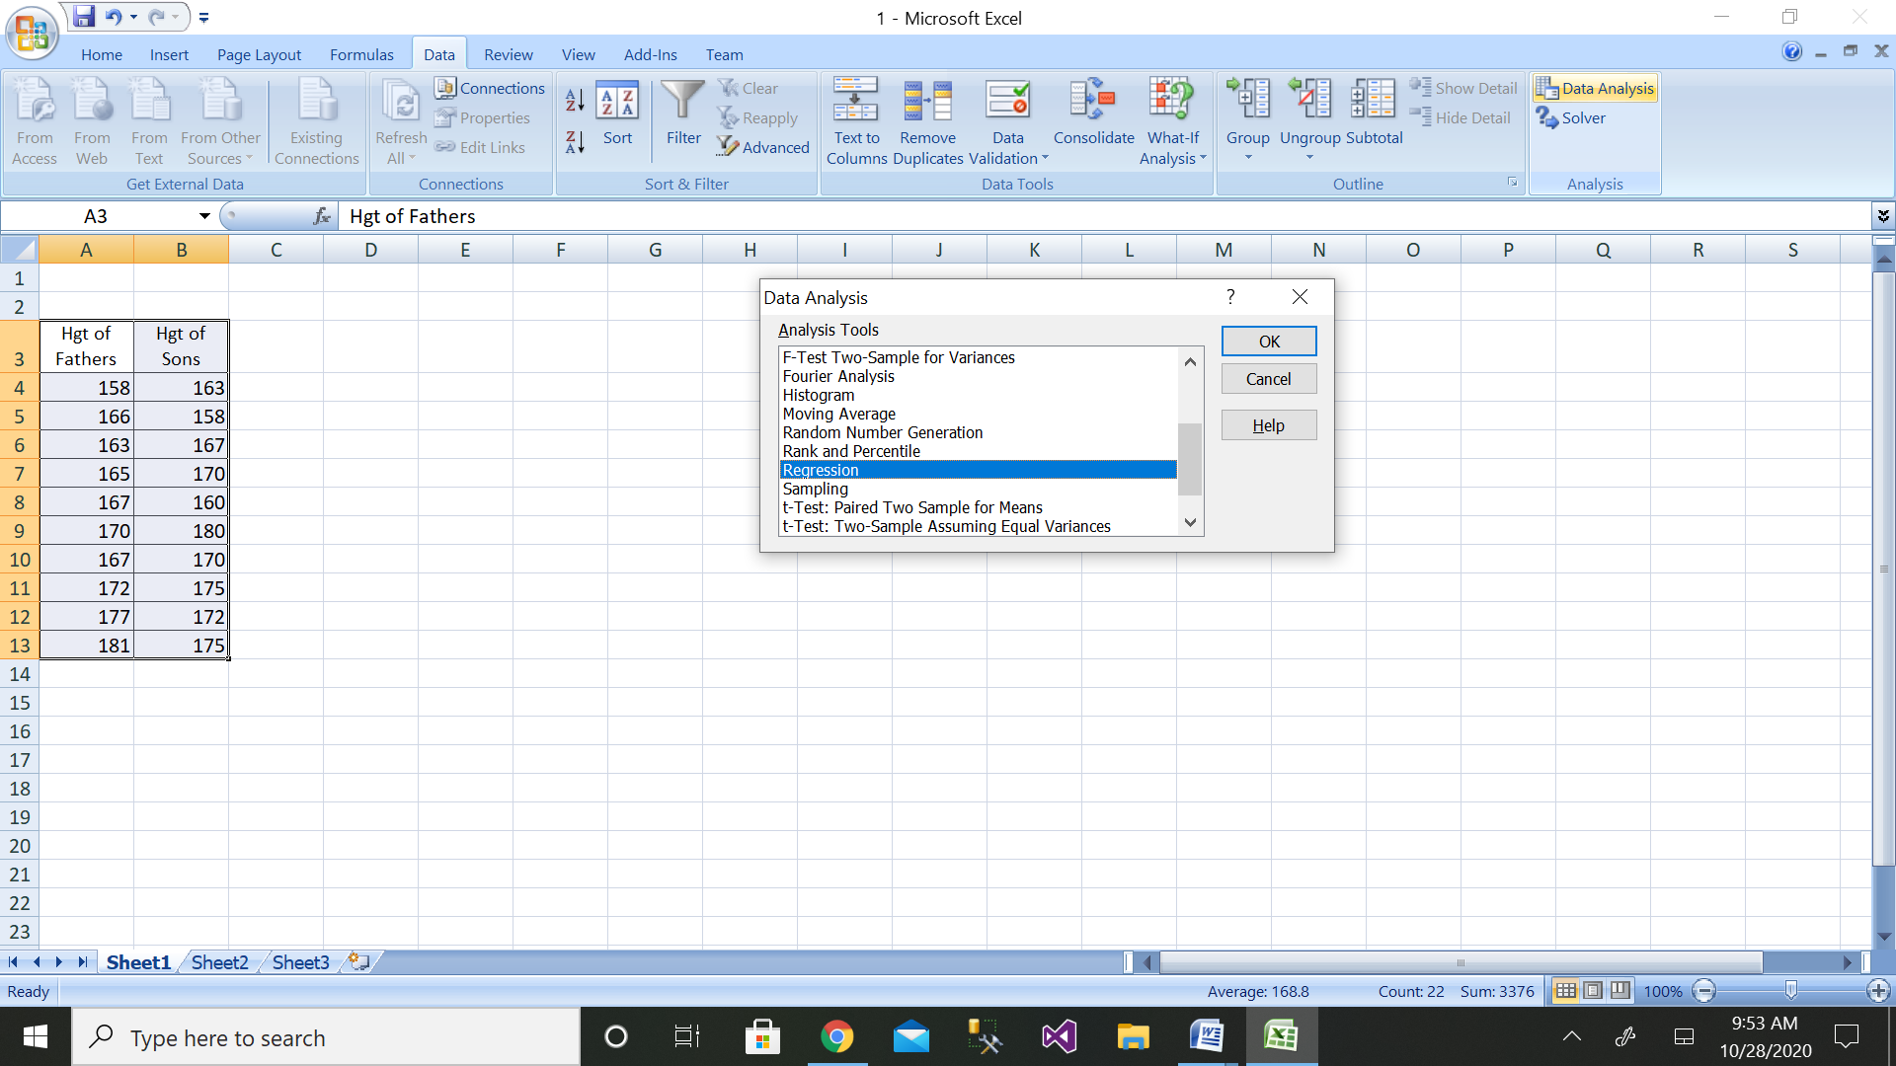

Step 5: Then select the range of dependent variable as shown above

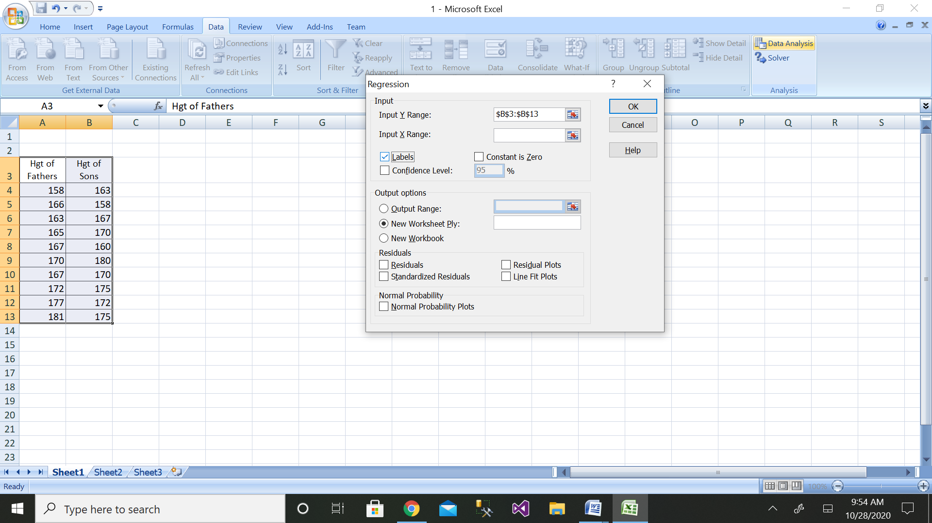

Step 6: After selecting both ranges click on ok button

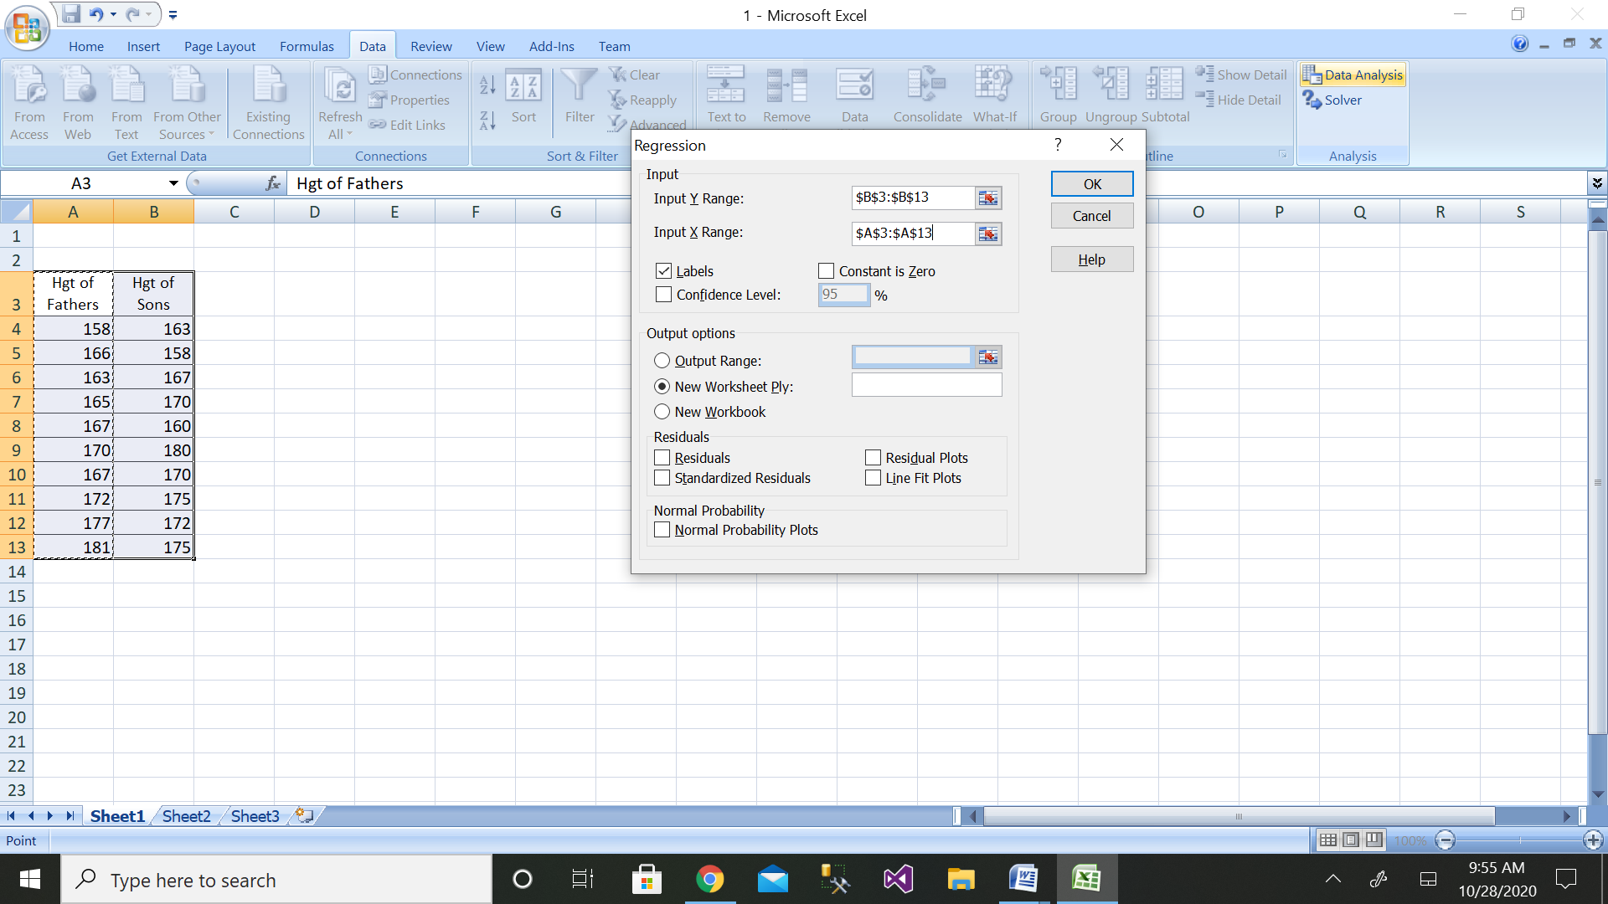

Step 7: We will get the output as shown with residual plot graph

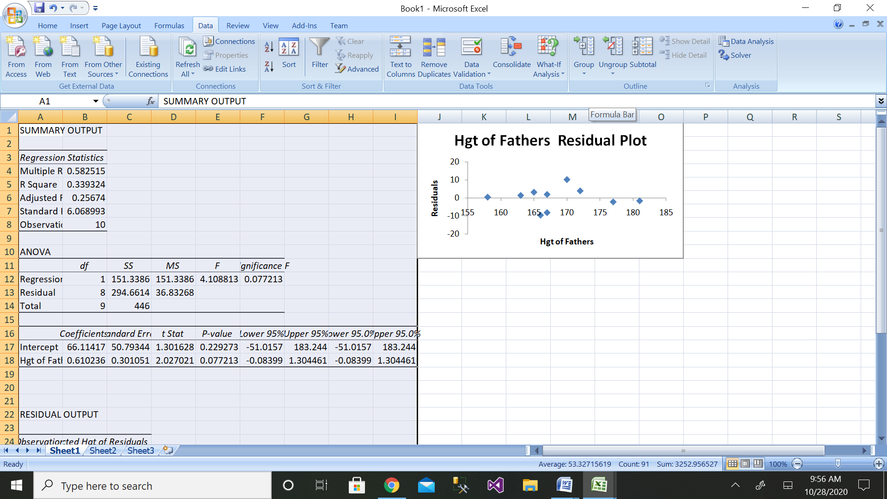

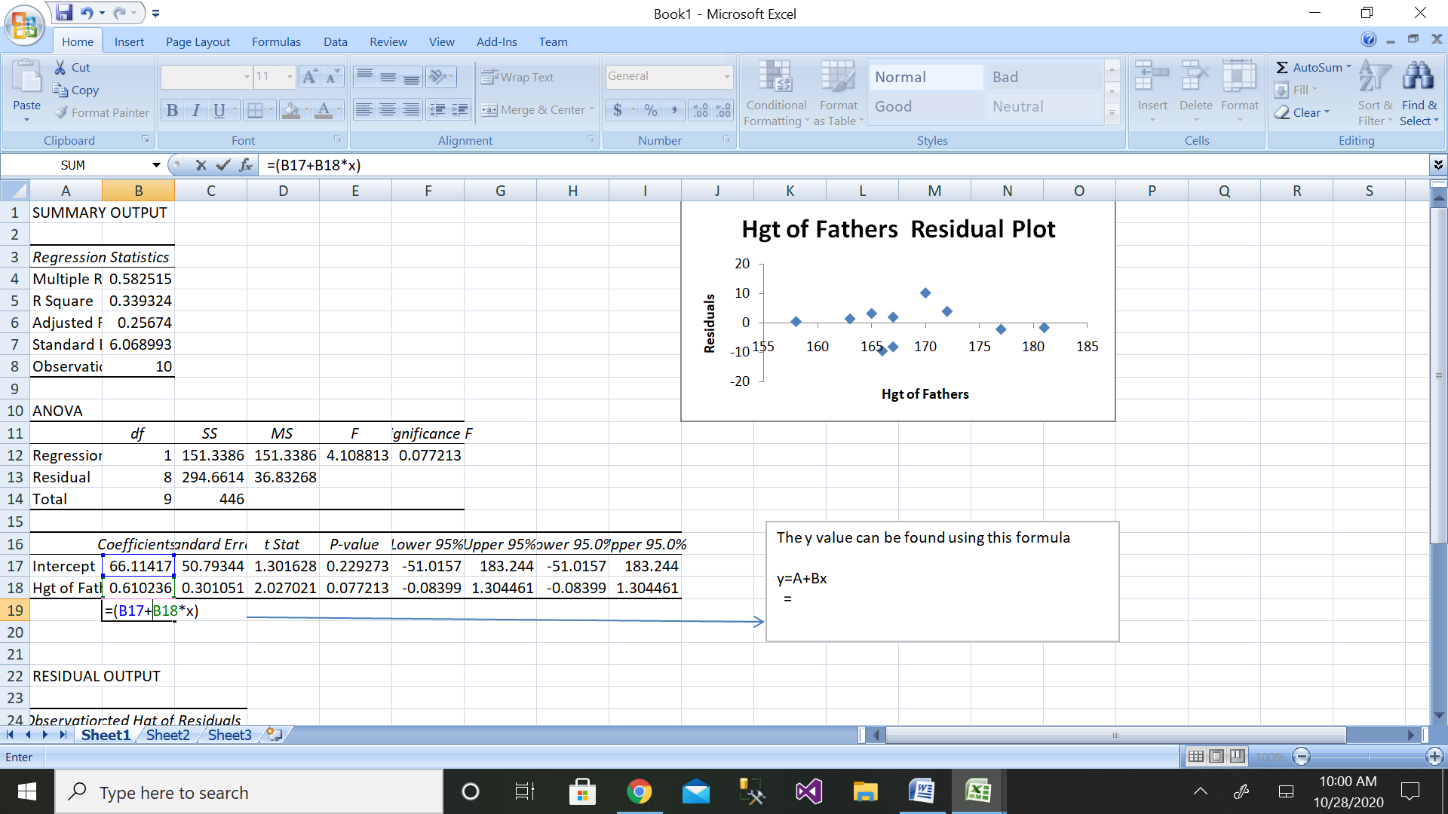

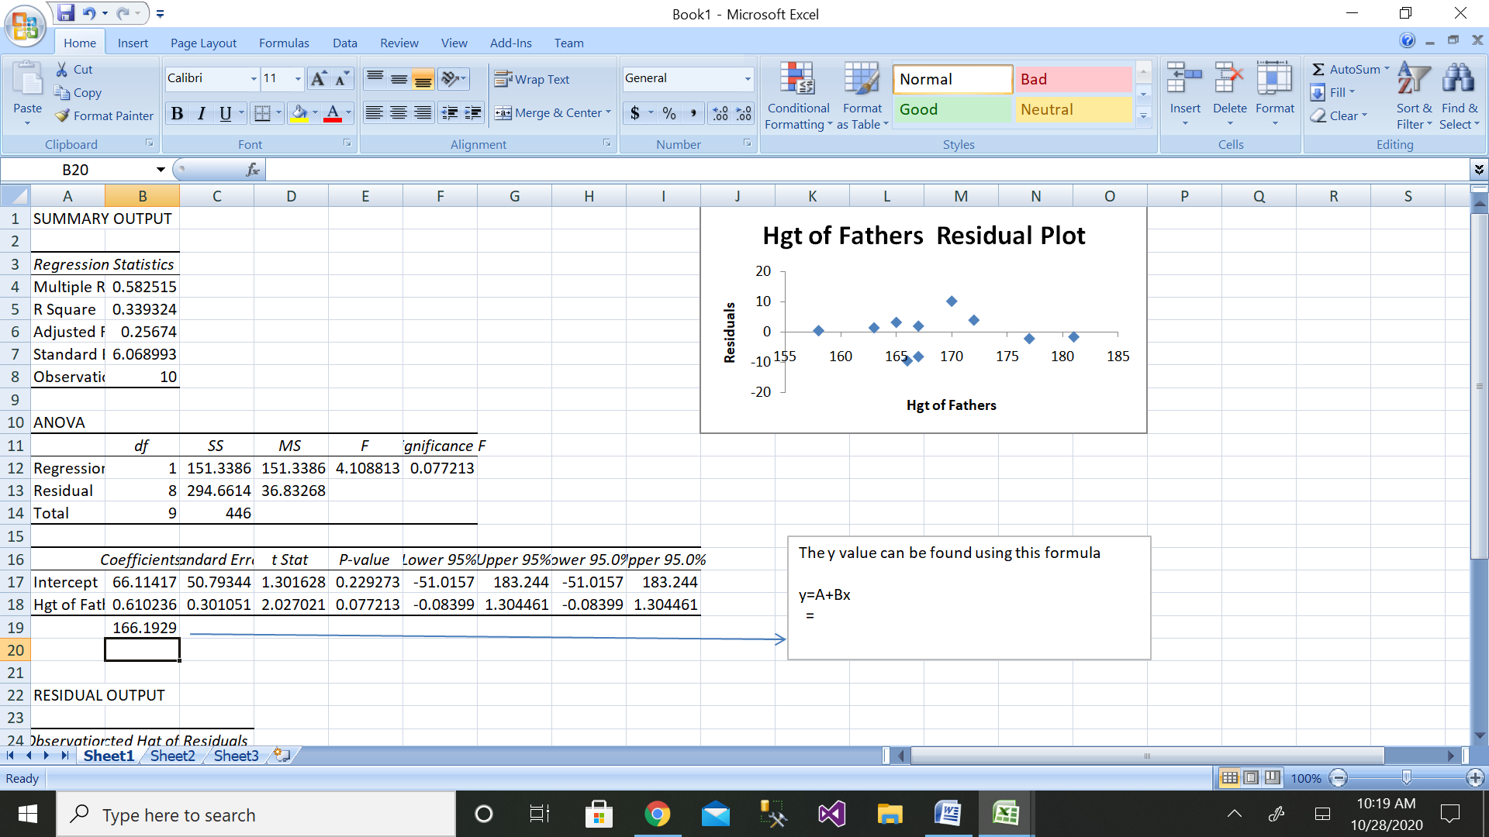

The height of son when son of father is 164cm is as follows:

Y=A+Bx

=66.11417+164*0.610236

=166.1929

Manual calculation

|  |  |  |  |  |  |  |
| --- | --- | --- | --- | --- | --- | --- |
| Sl. No. | height of father (x) | height of son(y) | x-mean(x) | y-mean(y) | x-mean(x) * y-mean(y) | x-mean(x)^2 |
| 1 | 158 | 163 | -10.6 | -6 | 63.6 | 112.36 |
| 2 | 166 | 158 | -2.6 | -11 | 28.6 | 6.76 |
| 3 | 163 | 167 | -5.6 | -2 | 11.2 | 31.36 |
| 4 | 165 | 170 | -3.6 | 1 | -3.6 | 12.96 |
| 5 | 167 | 160 | -1.6 | -9 | 14.4 | 2.56 |
| 6 | 170 | 180 | 1.4 | 11 | 15.4 | 1.96 |
| 7 | 167 | 170 | -1.6 | 1 | -1.6 | 2.56 |
| 8 | 172 | 175 | 3.4 | 6 | 20.4 | 11.56 |
| 9 | 177 | 172 | 8.4 | 3 | 25.2 | 70.56 |
| 10 | 181 | 175 | 12.4 | 6 | 74.4 | 153.76 |
|  |  |  |  |  |  |  |
|  | sum(x) | sum(y) | 0.00 | 0 | 248 | 406.40 |
|  | 1686 | 1690 |  |  |  |  |
|  | mean(x) | mean(y) |  |  |  |  |
|  | 168.6 | 169 |  |  |  |  |
|  |  |  |  |  |  |  |
|  | coefficient of regression=byx | ((sum(x-mean(x) *y-mean(y)) ) / (x-mean(x)^2) | 0.61023622 | 0.61023622 |  |  |
|  |  |  |  |  |  |  |
|  | calculate y intercept | A=mean(y)-byx*mean(x) |  | 66.11417323 |  |  |
|  |  |  |  |  |  |  |
|  | dependent variable=y=A+byx*x |  | 166.192913 |  |  |  |

2. Using the data file [DISPOSABLE INCOME AND VEHICLE SALES](https://wps.prenhall.com/wps/media/objects/973/997180/dataset_questions/disposable_income.xls), perform the following:

1. Plot a scatter diagram.
2. Determine the regression equation.
3. Plot the regression line (hint: use MS Excel's Add Trendline feature).
4. Compute the predicted vehicle sales for disposable income of $16,500 and of $17,900.

Compute the coefficient of determination and the coefficient of correlation

Solution: Sales data have been taken from dataset.

|  |  |
| --- | --- |
| disposable income | vehicle sales |
| 15000 | 200 |
| 28000 | 300 |
| 18000 | 180 |
| 19000 | 190 |
| 22000 | 220 |
| 25000 | 250 |
| 10000 | 100 |
| 29000 | 285 |

a)

Scatter diagram is as follows:

b) Regression equation is as follows:

y=A+Bx

c)Regression line:

d)

Step 1: Enter the data for Independent Variable x and dependent variable y as shown above 8 values

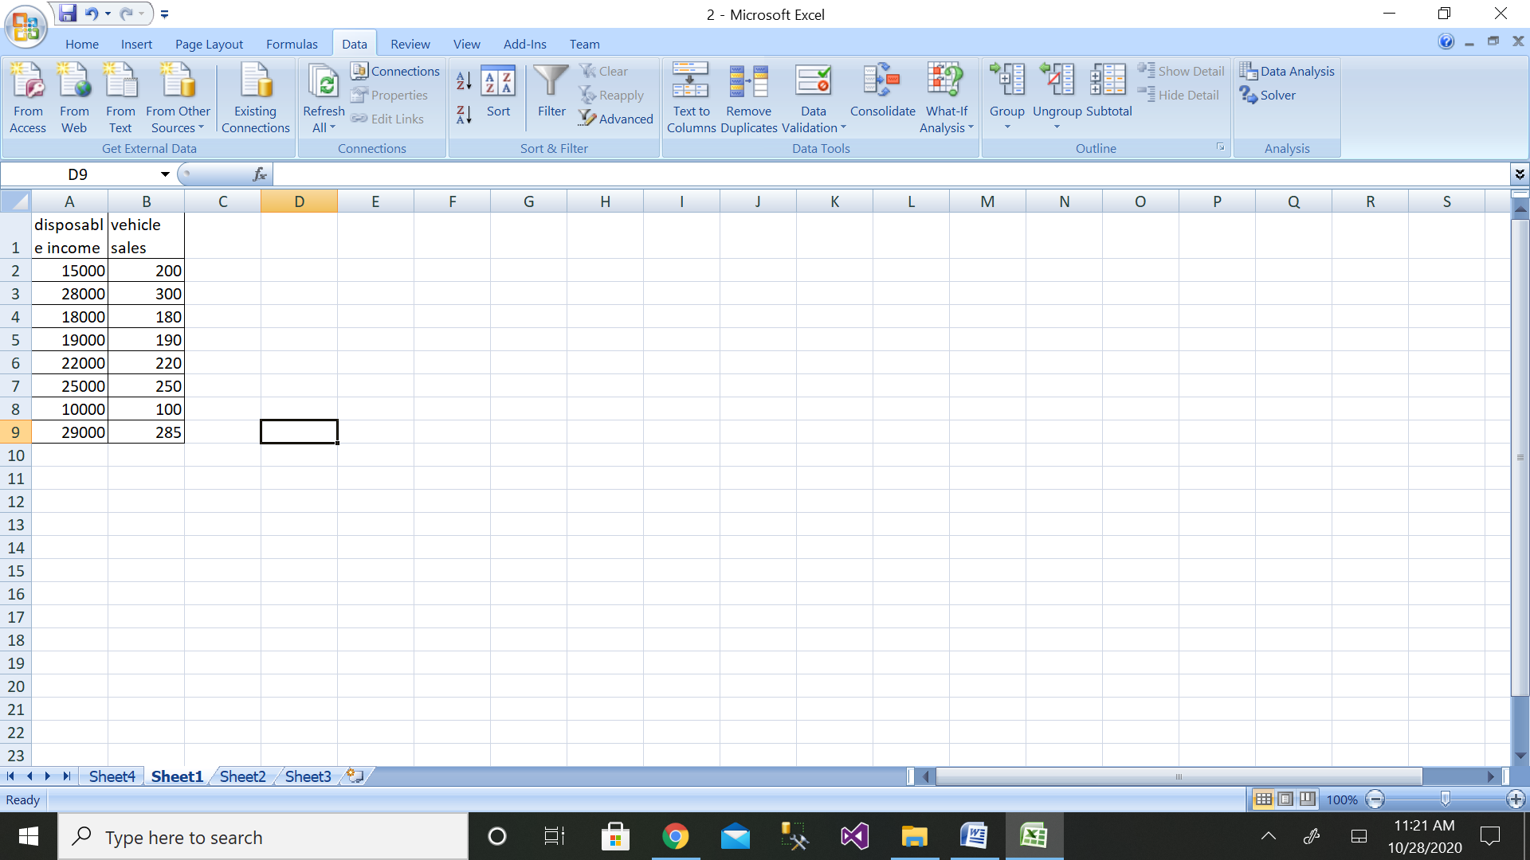

Step 2: Then click on the Data Analysis button

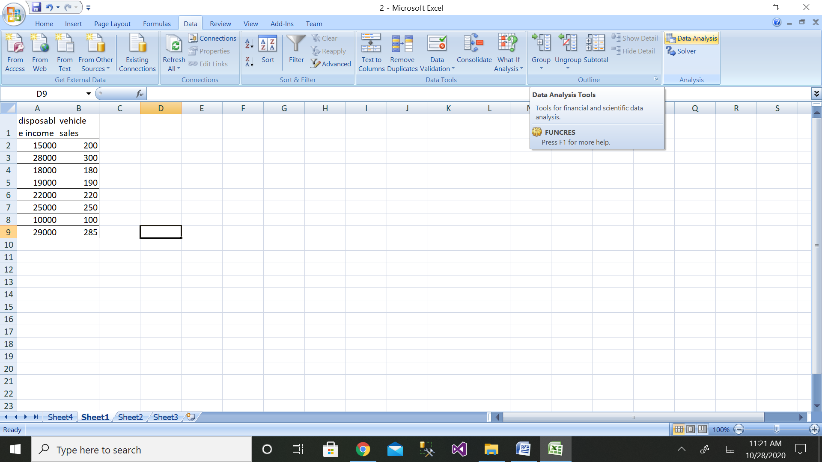

Step 4: Then click on the Regression button

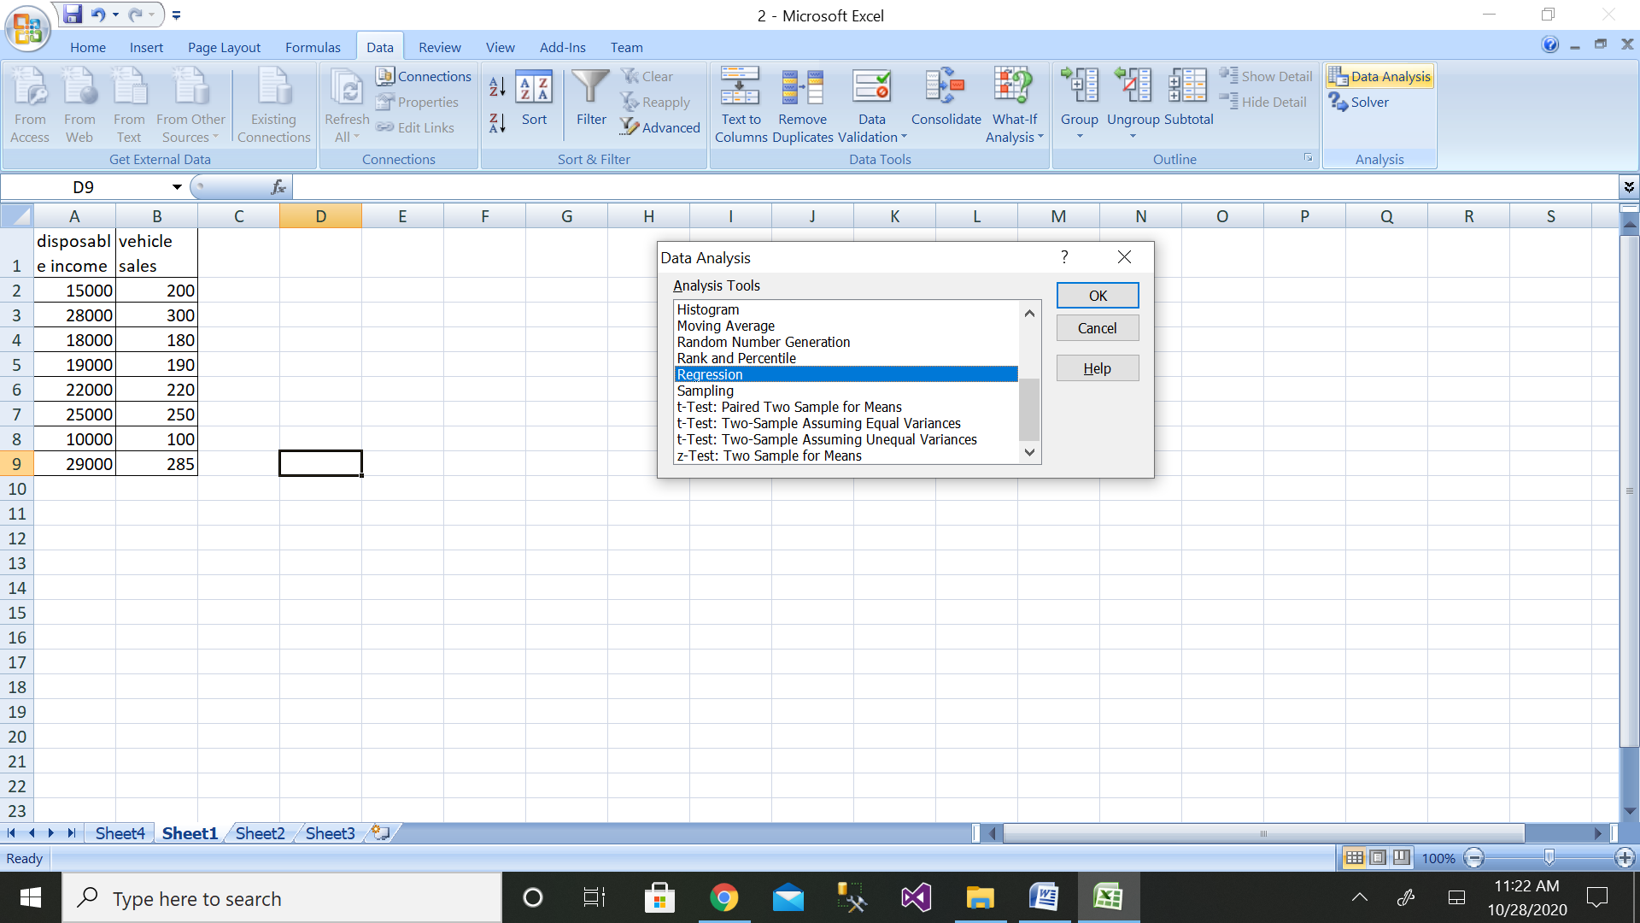

Step 4: Then select the range of dependent variable as shown above

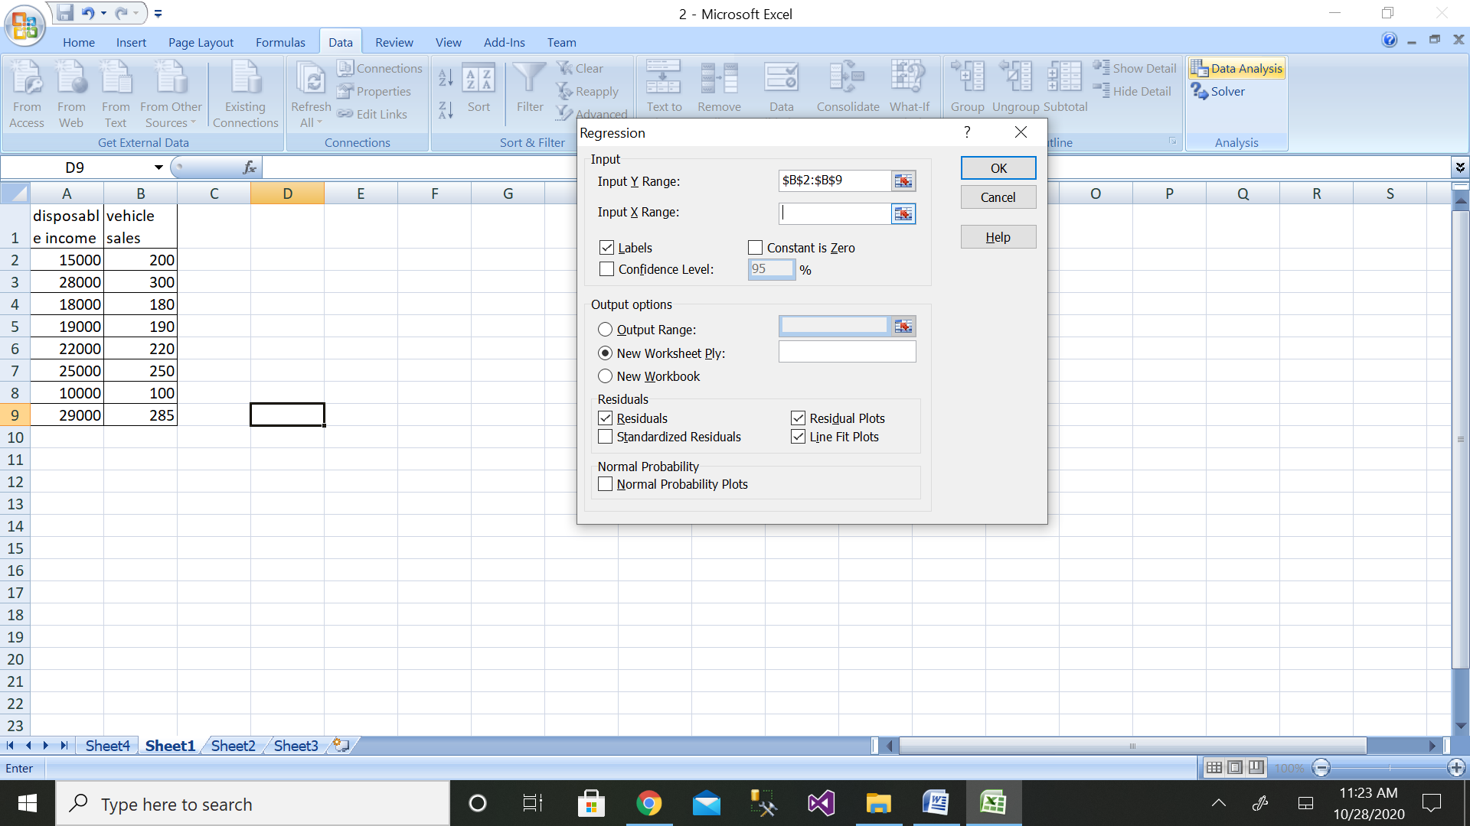

Step 6: After selecting both ranges click on ok button

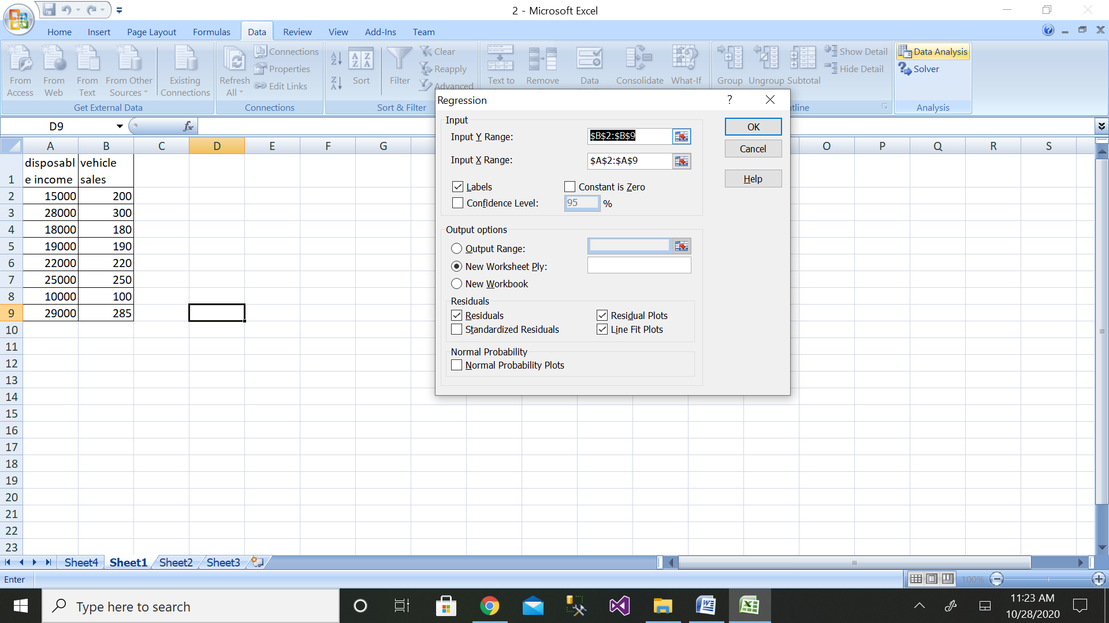

Step 7: We will get the output as shown with residual plot graph

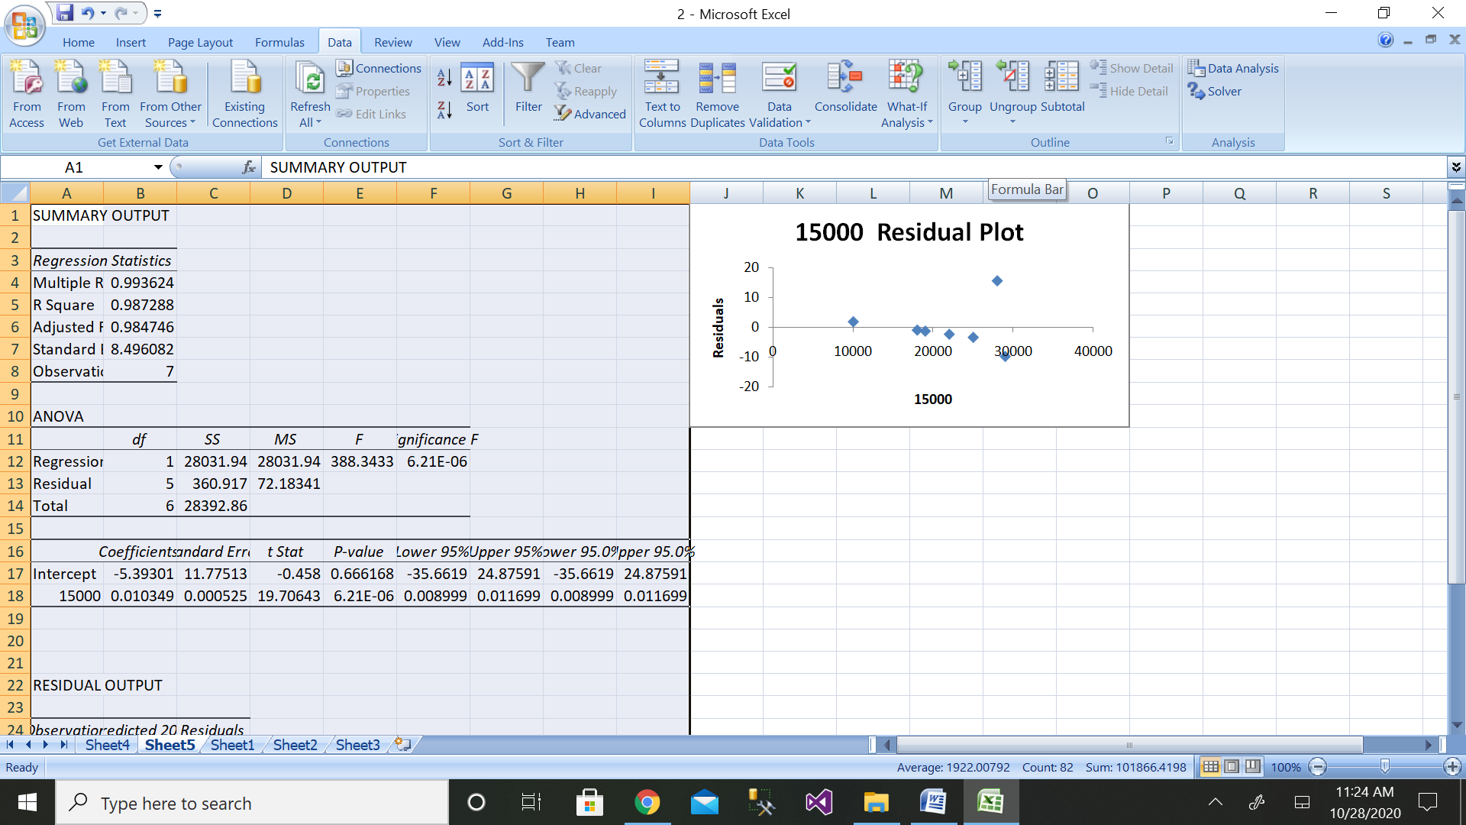

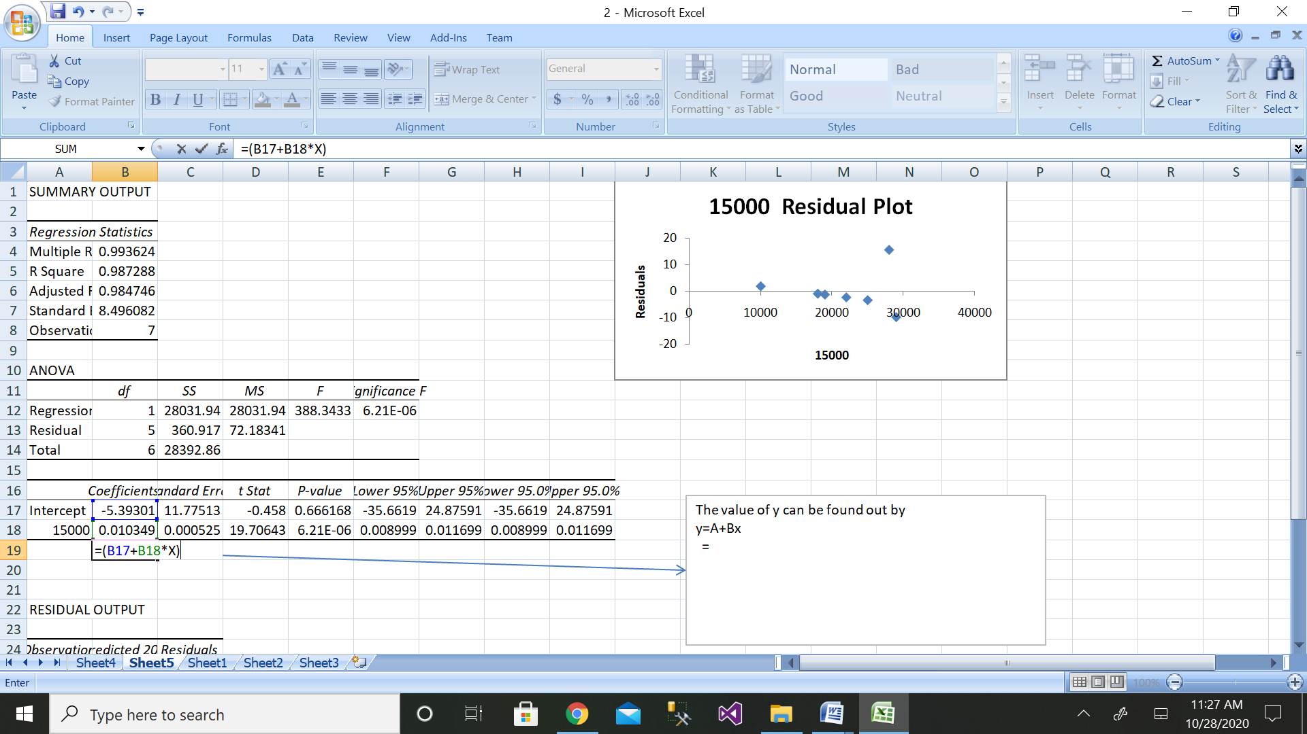

The value of sales when sales is 16500 and 17900 is

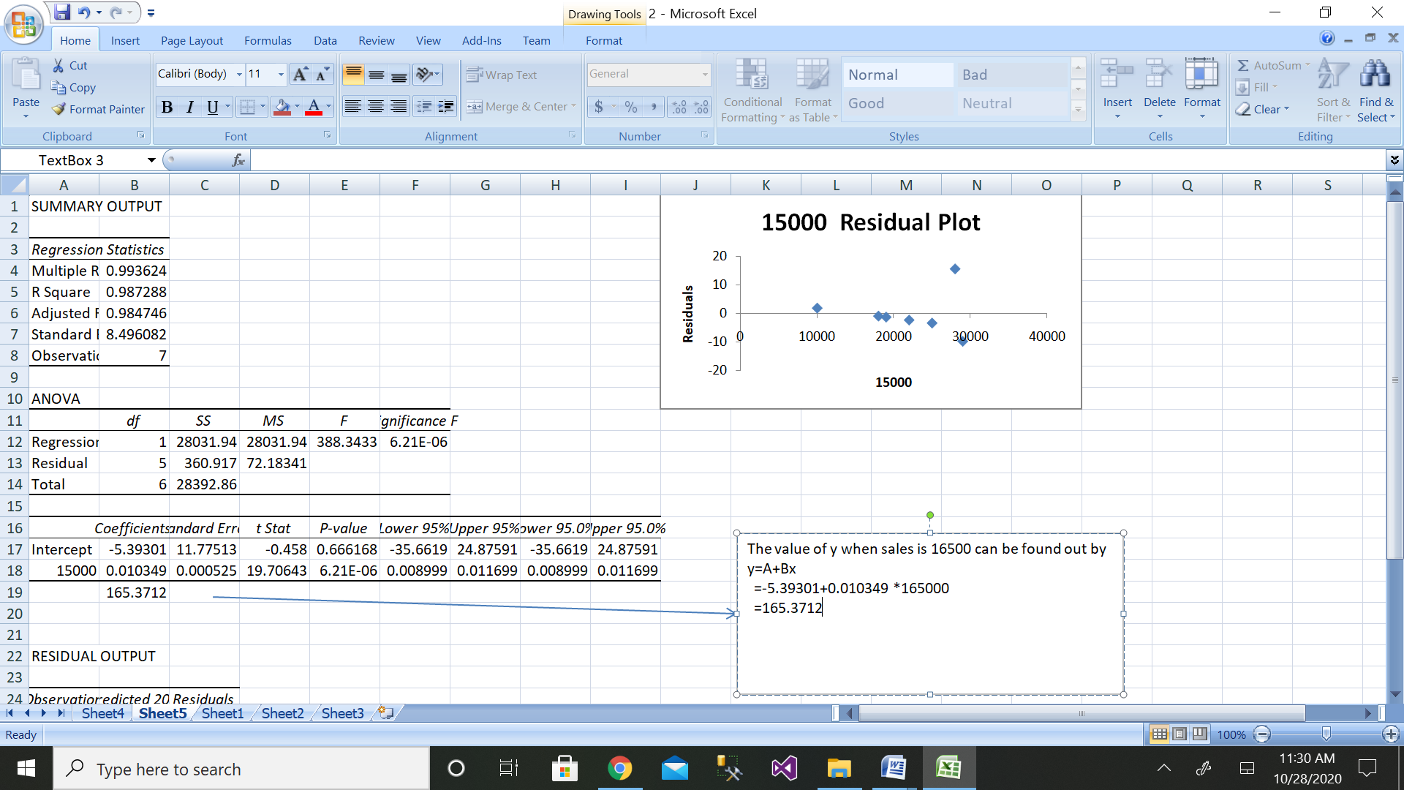

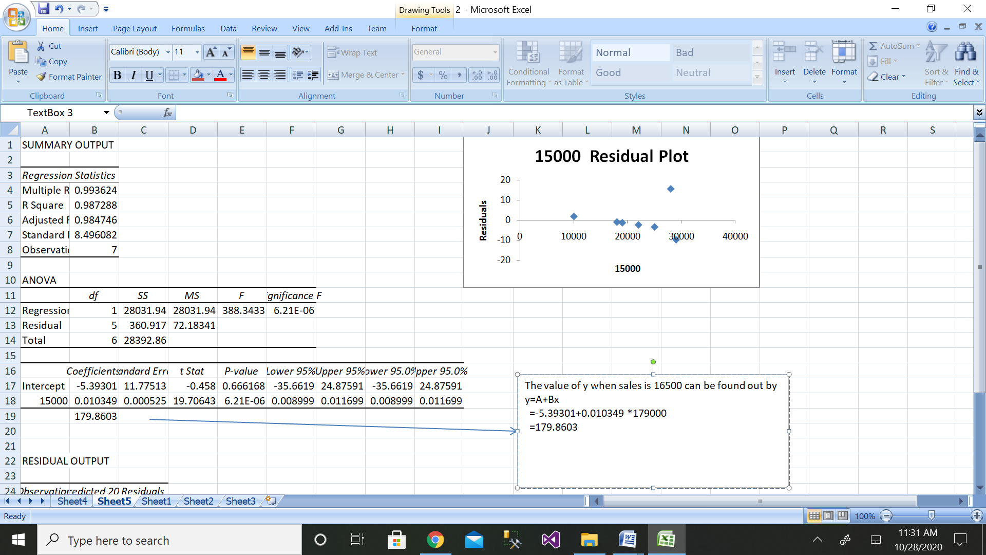

e) coefficient of determination and the coefficient of correlation

r=∑(xi−¯x)(yi−¯y ) / √∑(xi−¯x)2∑(yi−¯y)2

SSR=∑(y^−y¯)2

SSE=∑(yi−y^)2

SSTO=∑(y−y¯)2

r2=SSR/SSTO=1−SSE/SSTO

coefficient of correlation and coefficient of determination can be found out by:

|  |  |  |  |  |  |  |
| --- | --- | --- | --- | --- | --- | --- |
| disposable income(x) | sales(y) | x-mean(x) | y-mean(y) | x-mean(x)^2 | y-mean(y)^2 | x-mean(x)*y-mean(y) |
| 15000 | 200 | -5750 | -15.625 | 33062500 | 244.1406 | 89843.75 |
| 28000 | 300 | 7250 | 84.375 | 52562500 | 7119.141 | 611718.8 |
| 18000 | 180 | -2750 | -35.625 | 7562500 | 1269.141 | 97968.75 |
| 19000 | 190 | -1750 | -25.625 | 3062500 | 656.6406 | 44843.75 |
| 22000 | 220 | 1250 | 4.375 | 1562500 | 19.14063 | 5468.75 |
| 25000 | 250 | 4250 | 34.375 | 18062500 | 1181.641 | 146093.8 |
| 10000 | 100 | -10750 | -115.625 | 115562500 | 13369.14 | 1242969 |
| 29000 | 285 | 8250 | 69.375 | 68062500 | 4812.891 | 572343.8 |
|  |  |  |  |  |  |  |
|  |  |  |  |  |  |  |
| sum(x) | sum(y) | 0.00 | 0 | 299500000.00 | 28671.88 | 2811250 |
| 166000 | 1725 |  |  |  |  |  |
| mean(x) | mean(y) |  |  |  |  |  |
| 20750 | 215.625 |  |  |  |  |  |
|  |  |  |  |  |  |  |
| coefficient of regressionbyx= | ((sum(x-mean(x) *y-mean(y)) ) / (x-mean(x)^2) | 0.01 |  |  |  |  |
|  |  |  |  |  |  |  |
| calculate y intercept | A=mean(y)-byx*mean(x) |  | 20.85559265 |  |  |  |
|  |  |  |  |  |  |  |
| dependent variable=y=A+byx*x |  |  | 175.7324708 | when x=16500 |  |  |
|  |  |  |  |  |  |  |
| correlation | 0.959341 |  |  |  |  |  |
|  |  |  |  |  |  |  |
| determination=SSR |  | 30881.9013 |  |  |  |  |
|  |  |  |  |  |  |  |
|  | SSTO= | 28671.88 |  |  |  |  |
|  |  |  |  |  |  |  |
| So the answer is | 1.0770797 |  |  |  |  |  |

3.Managers model costs in order to make predictions. The cost data in the data file [INDIRECT COSTS AND MACHINE HOURS](https://wps.prenhall.com/wps/media/objects/973/997180/dataset_questions/indirect_costs_machine_hours.xls) show the indirect manufacturing costs of an ice-skate manufacturer. Indirect manufacturing costs include maintenance costs and setup costs. Indirect manufacturing costs depend on the number of hours the machines are used, called machine hours. Based on the data for January to December, perform the following operations.

1. Plot a scatter diagram.
2. Determine the regression equation.
3. Plot the regression line (hint: use MS Excel's Add Trendline feature).
4. Compute the predicted indirect manufacturing costs for 300 machine hours and for 430 machine hours.

Compute the coefficient of determination and the coefficient of correlation

Solution:

Step 1:

|  |  |  |
| --- | --- | --- |
| month | no. of hours machine used | machine cost |
| Jan | 50 | 100 |
| Feb | 350 | 700 |
| Mar | 100 | 200 |
| Apr | 400 | 800 |
| May | 150 | 300 |
| Jun | 450 | 900 |
| Jul | 200 | 400 |
| Aug | 500 | 1000 |
| Sept | 250 | 500 |
| Oct | 550 | 1100 |
| Nov | 300 | 600 |
| Dec | 600 | 1200 |

1. Scatter diagram is as follows:

b) Regression equation is as follows:

y=A+Bx

c)Regression line:

d)

Step 1: Enter the data for Independent Variable x and dependent variable y as shown above 12 values

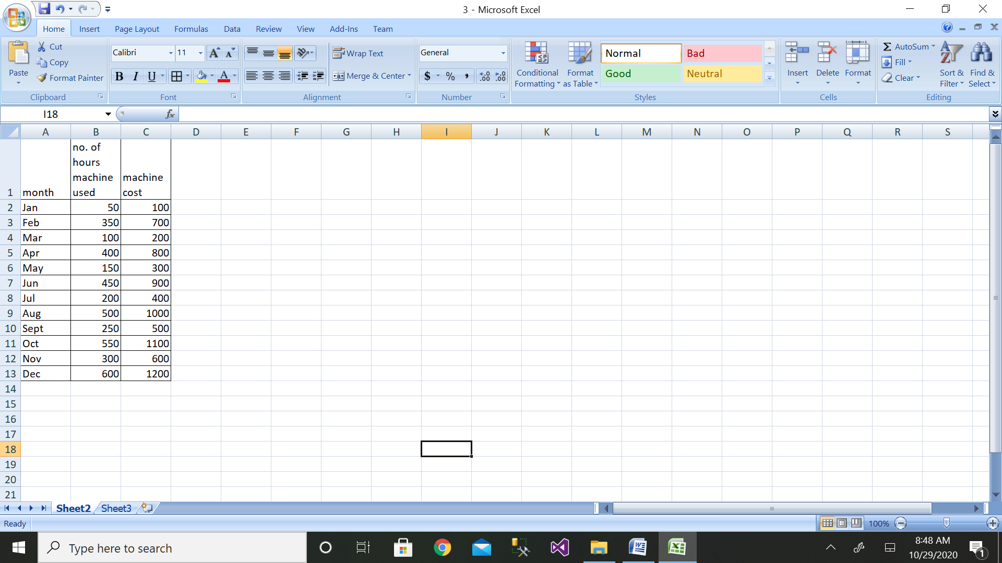

Step 2: Then click on the Data Analysis button

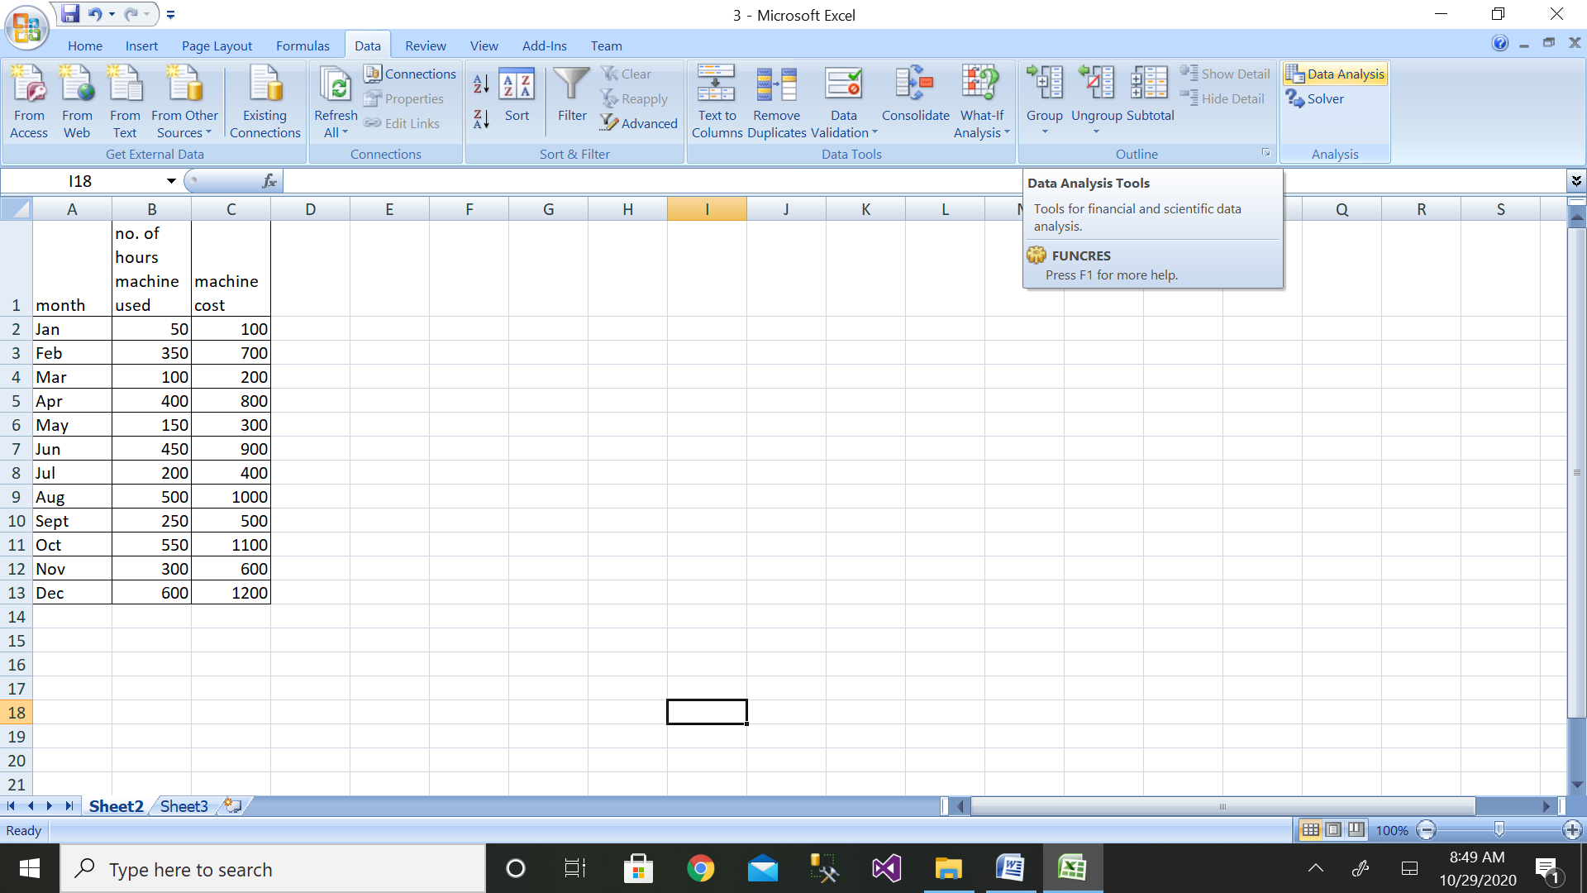

Step 3: Then click on the Regression button

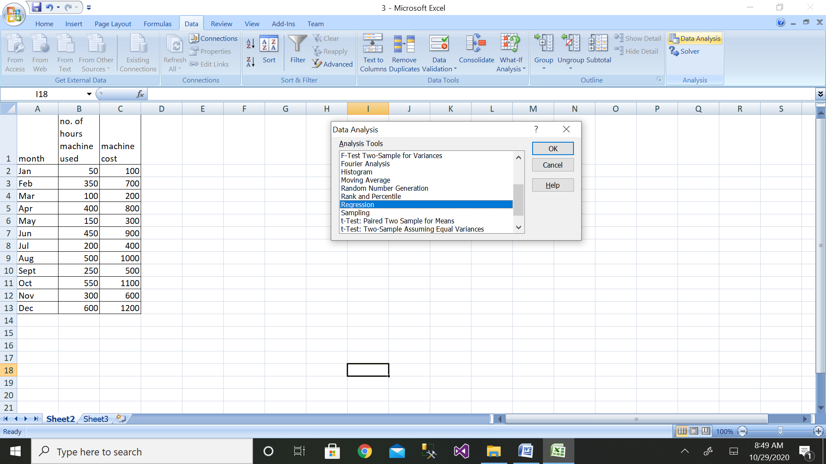

Step 4: Then select the range of dependent variable as shown above

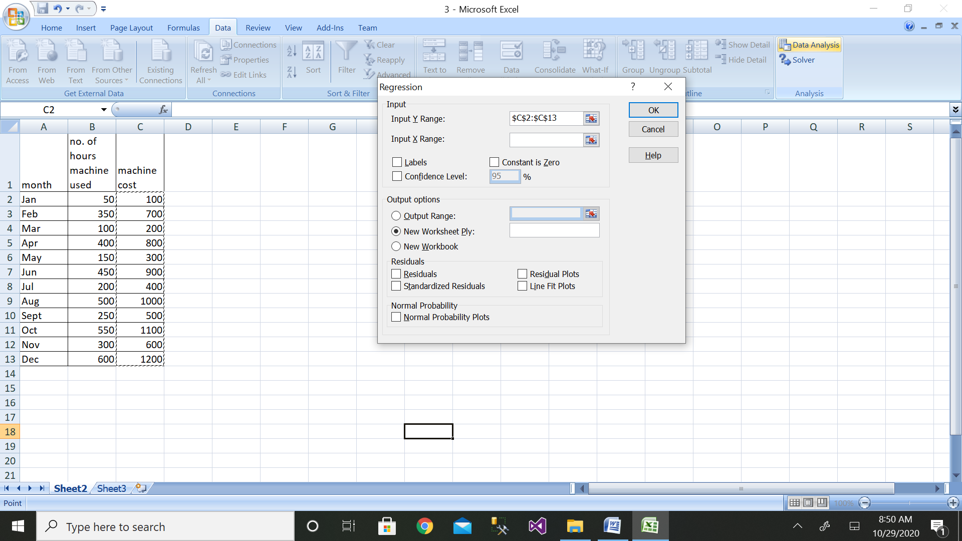

Step 5: After selecting both ranges click on ok button

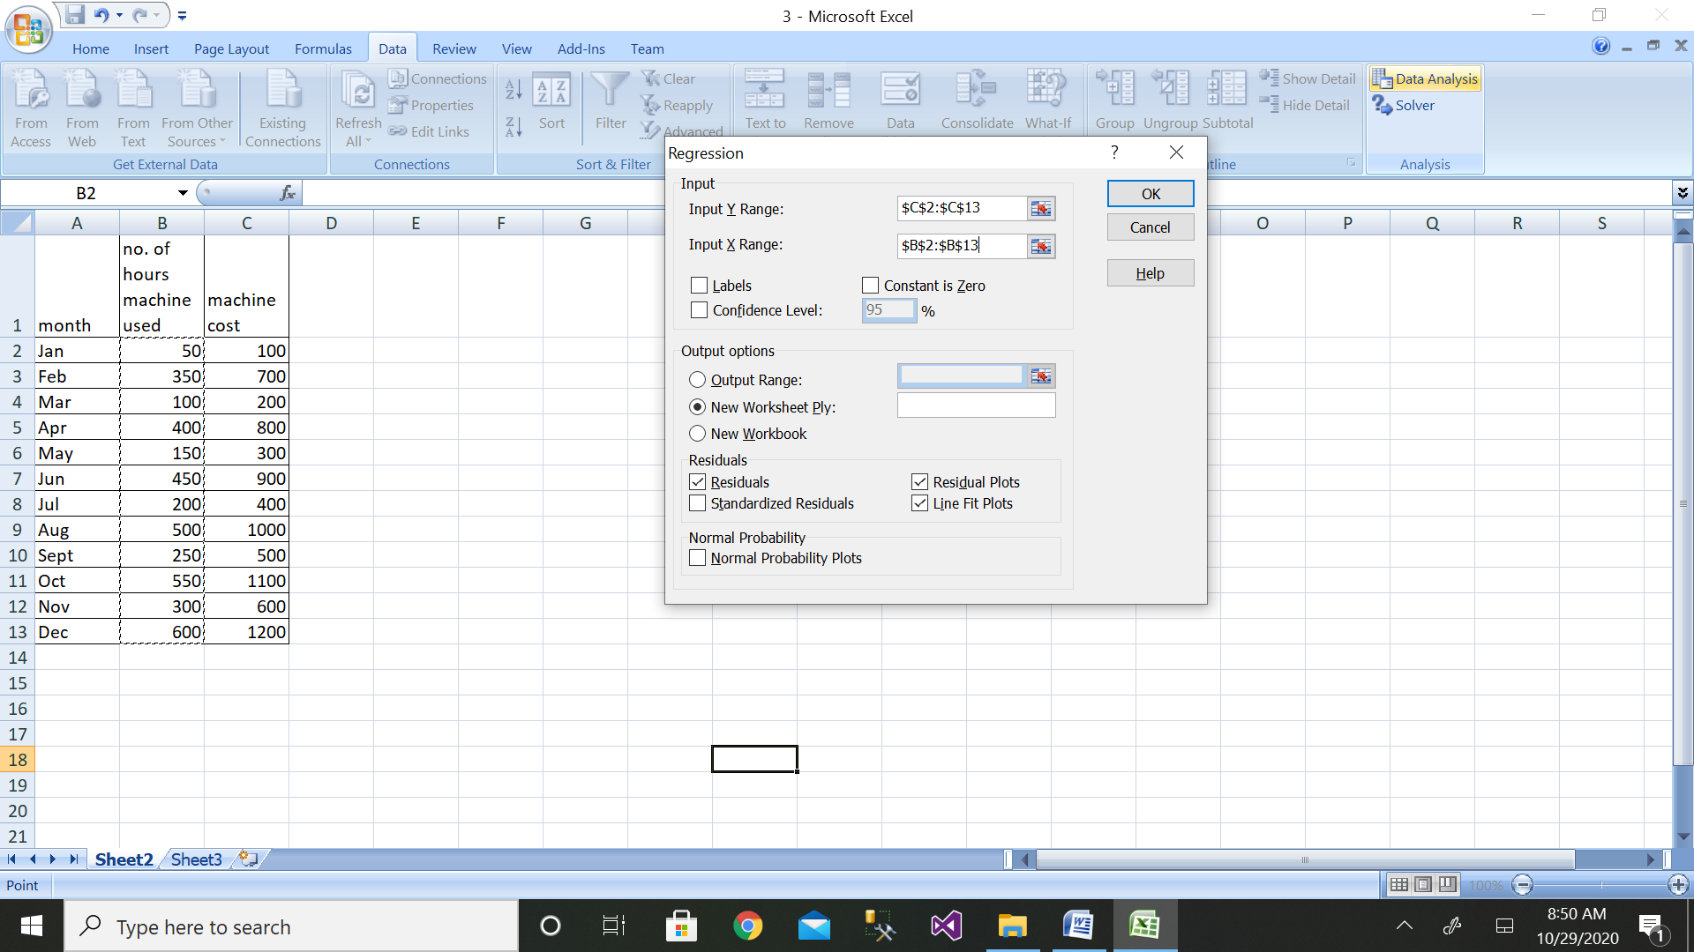

Step 6: We will get the output as shown with residual plot graph

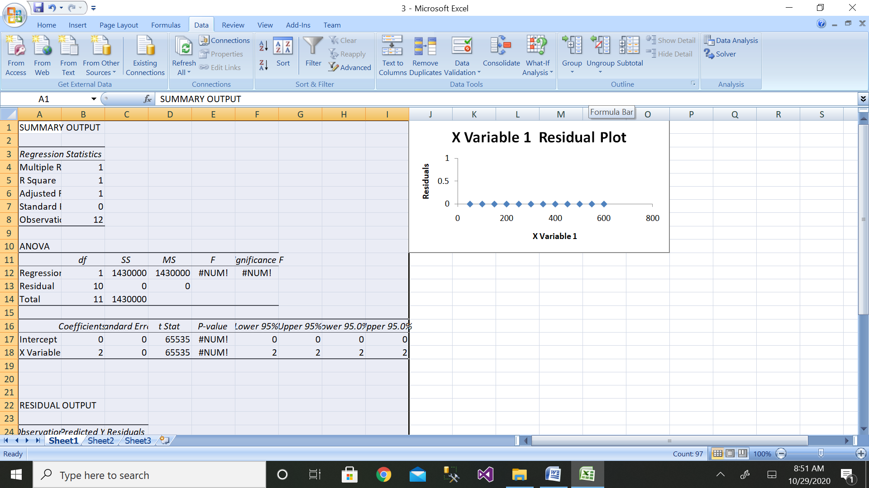

The value of cost when the machine hours are 300 and 430 are:

Y300=0+300*2

=600

Y430=0+430*2

=860

e) coefficient of determination and the coefficient of correlation

r=∑(xi−¯x)(yi−¯y ) / √∑(xi−¯x)2∑(yi−¯y)2

SSR=∑(y^−y¯)2

SSE=∑(yi−y^)2

SSTO=∑(y−y¯)2

r2=SSR/SSTO=1−SSE/SSTO

|  |  |  |  |  |  |  |
| --- | --- | --- | --- | --- | --- | --- |
| machine hours(x) | cost(y) | x-mean(x) | y-mean(y) | x-mean(x)^2 | y-mean(y)^2 | x-mean(x)*y-mean(y) |
| 50 | 100 | -275 | -550 | 75625 | 302500 | 151250 |
| 350 | 700 | 25 | 50 | 625 | 2500 | 1250 |
| 100 | 200 | -225 | -450 | 50625 | 202500 | 101250 |
| 400 | 800 | 75 | 150 | 5625 | 22500 | 11250 |
| 150 | 300 | -175 | -350 | 30625 | 122500 | 61250 |
| 450 | 900 | 125 | 250 | 15625 | 62500 | 31250 |
| 200 | 400 | -125 | -250 | 15625 | 62500 | 31250 |
| 500 | 1000 | 175 | 350 | 30625 | 122500 | 61250 |
| 250 | 500 | -75 | -150 | 5625 | 22500 | 11250 |
| 550 | 1100 | 225 | 450 | 50625 | 202500 | 101250 |
| 300 | 600 | -25 | -50 | 625 | 2500 | 1250 |
| 600 | 1200 | 275 | 550 | 75625 | 302500 | 151250 |
|  |  |  |  |  |  |  |
| sum(x) | sum(y) | 0.00 | 0 | 357500.00 | 1430000 | 715000 |
| 3900 | 7800 |  |  |  |  |  |
| mean(x) | mean(y) |  |  |  |  |  |
| 325 | 650 |  |  |  |  |  |
|  |  |  |  |  |  |  |
| coefficient of regressionbyx= | ((sum(x-mean(x) *y-mean(y)) ) / (x-mean(x)^2) | 2.00 |  |  |  |  |
|  |  |  |  |  |  |  |
| calculate y intercept | A=mean(y)-byx*mean(x) |  | 0 |  |  |  |
|  |  |  |  |  |  |  |
| dependent variable=y=A+byx*x |  |  | 860 | when x=430 |  |  |
|  |  |  |  |  |  |  |
| correlation | 1 |  |  |  |  |  |
|  |  |  |  |  |  |  |
| determination=SSR |  | 44100 |  |  |  |  |
|  |  |  |  |  |  |  |
|  | SSTO= | 44102 |  |  |  |  |
|  |  |  |  |  |  |  |
| So the coeff of determination is | 0.9999547 |  |  |  |  |  |

4. Apply multiple linear regression to predict the stock index price which is a dependent variable of a fictitious economy based on two independent / input variables interest rate and unemployment rate.

|  |  |  |  |  |
| --- | --- | --- | --- | --- |
| year | month | interest rate | unemployment rate | stock index price |
| 2020 | 10 | 2.75 | 5.3 | 1464 |

Solution:

|  |  |  |  |  |
| --- | --- | --- | --- | --- |
| **year** | **month** | **interest rate** | **unemployment rate** | **stock index price** |
| 2020 | 10 | 2.75 | 5.3 | 1464 |
| 2020 | 1 | 2.5 | 5.1 | 1300 |
| 2020 | 2 | 2.4 | 5 | 1200 |
| 2020 | 3 | 2 | 4.5 | 1000 |
| 2020 | 4 | 3 | 5.5 | 1500 |
| 2020 | 6 | 3.5 | 5.7 | 1650 |
| 2020 | 8 | 2.9 | 5 | 1600 |
| 2020 | 9 | 2 | 5 | 1400 |

Step 2: Enter the data for Independent Variable x and dependent variable y as shown above 8 values

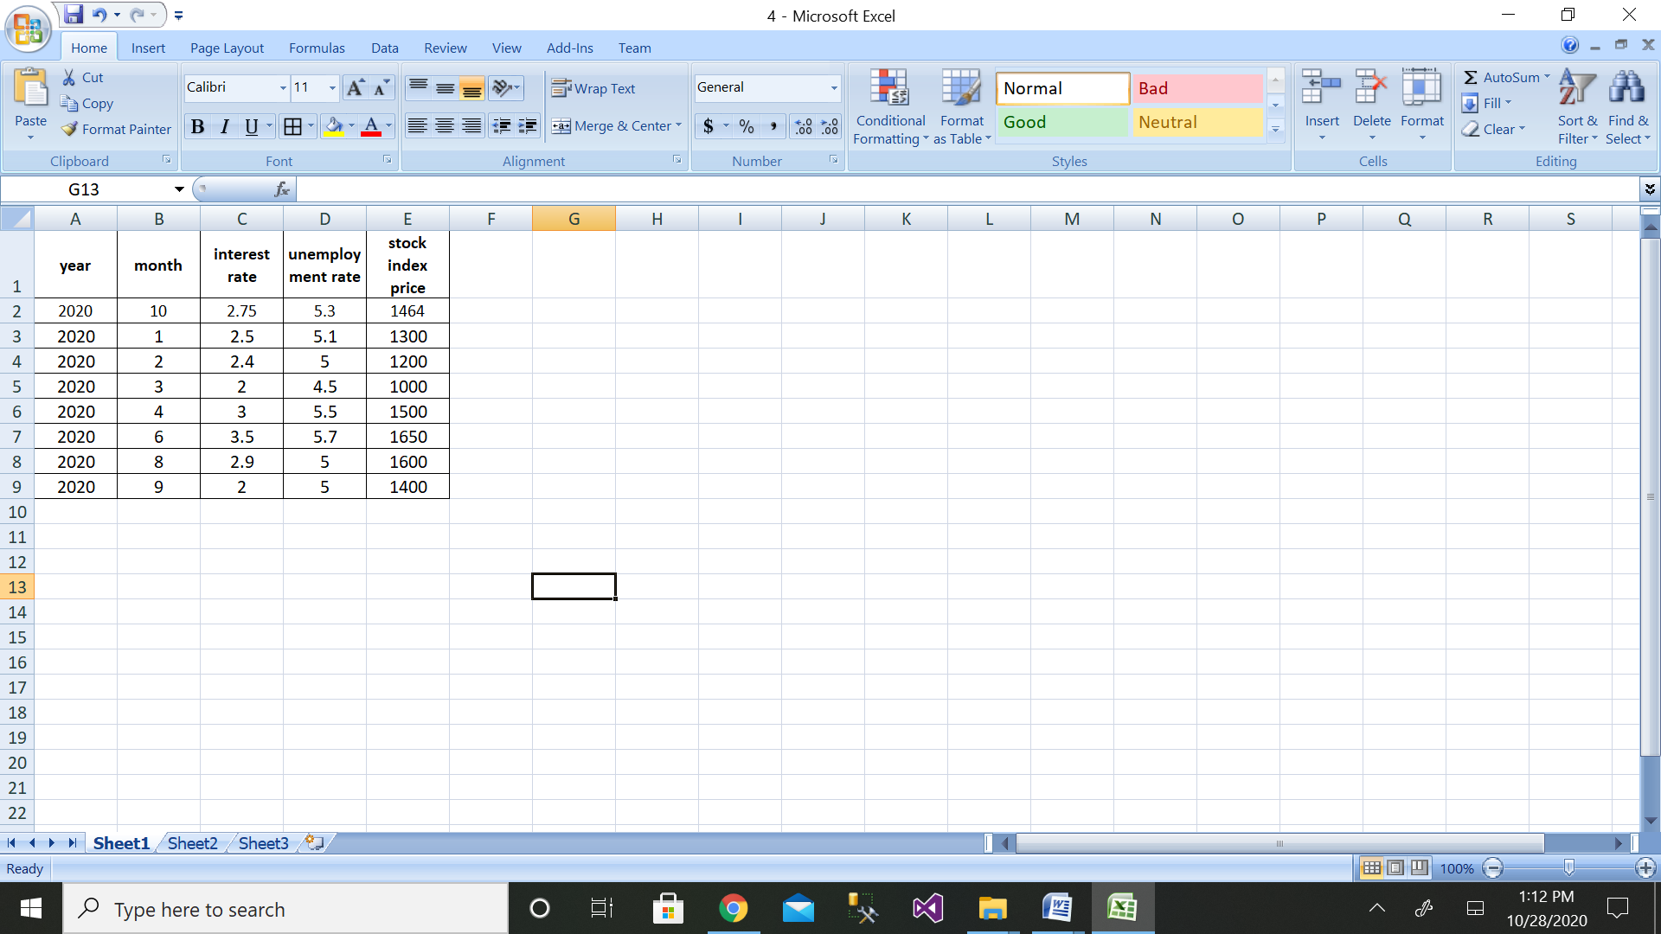

Step 3: Then click on the Data Analysis button

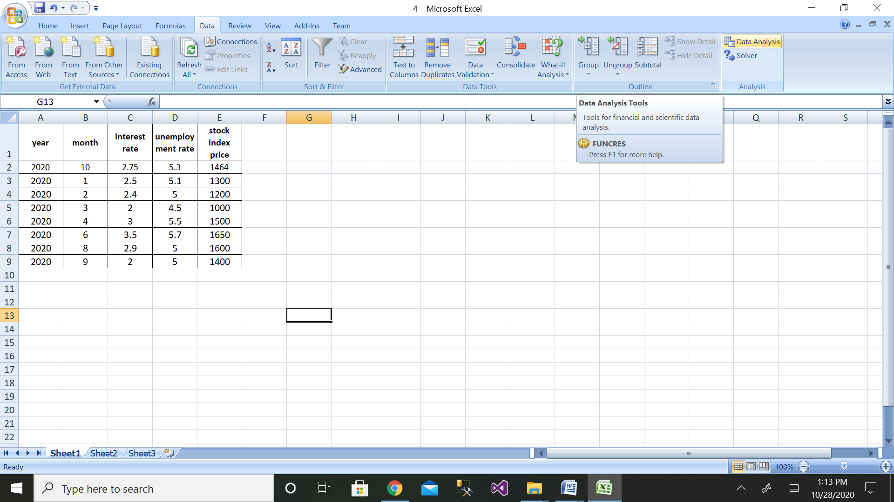

Step 4: Then click on the Regression button

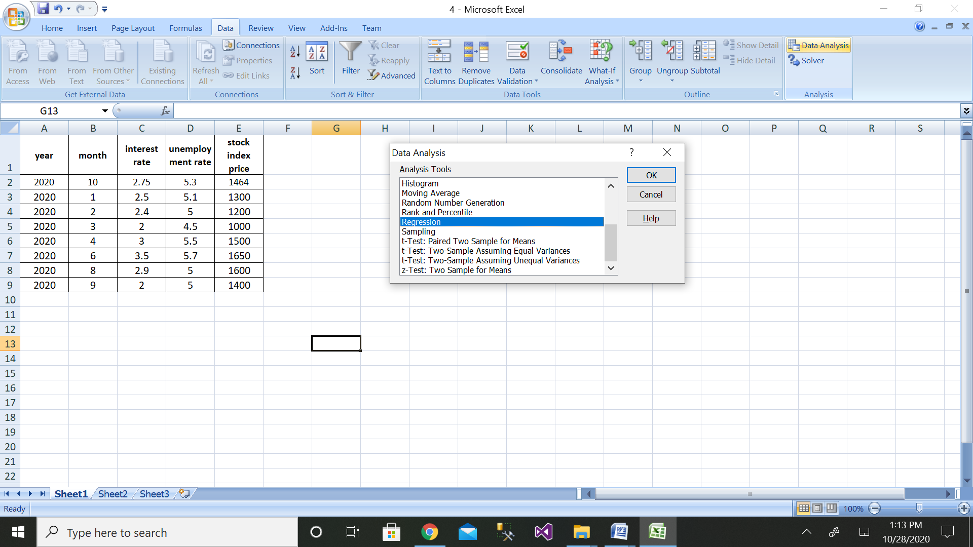

Step 5: Then select the range of dependent variable as shown above

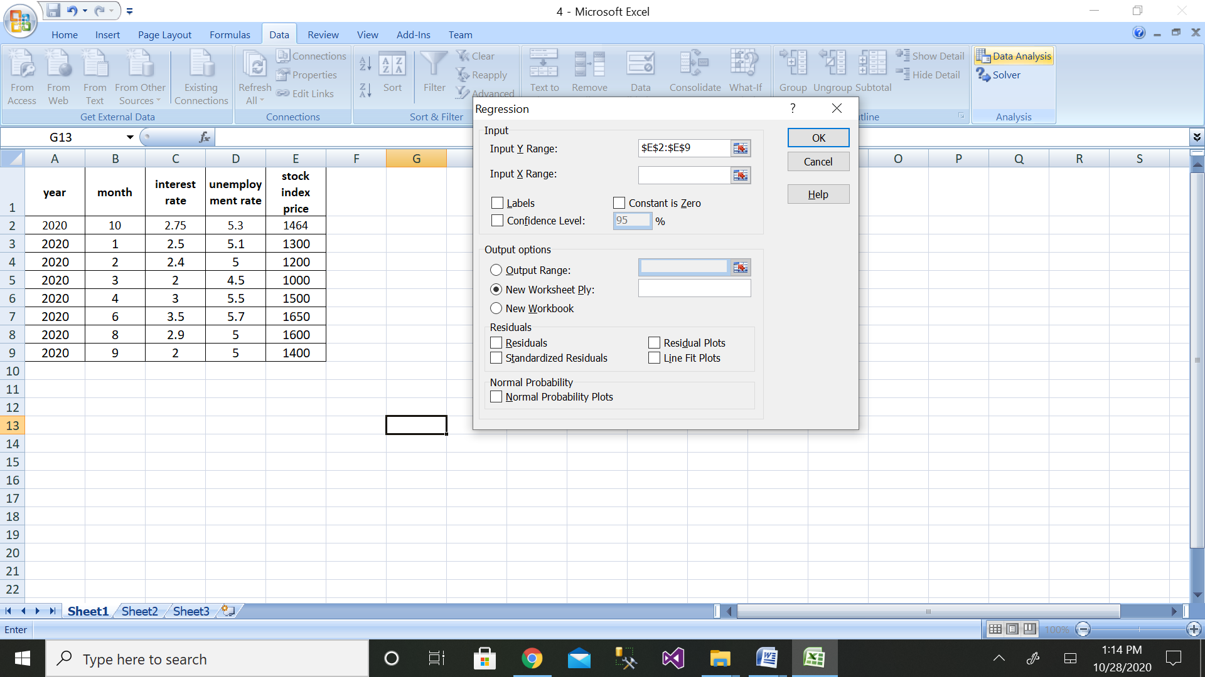

Step 6: After selecting both ranges click on ok button

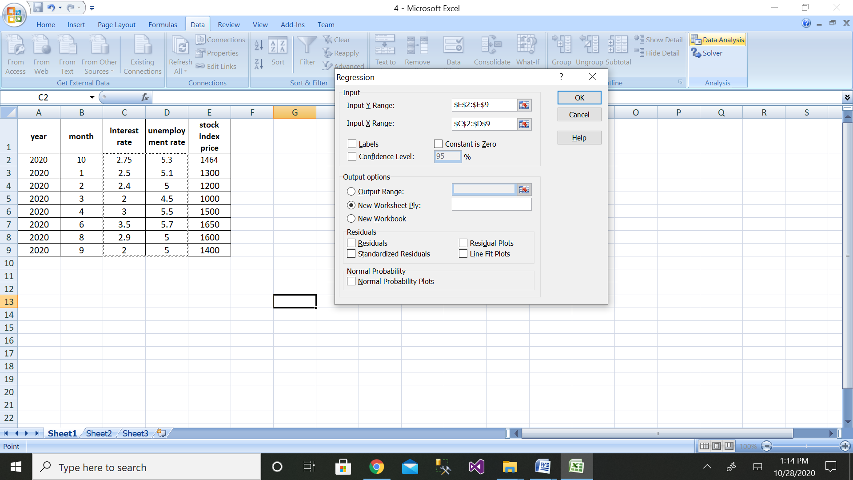

Step 7: We will get the output as shown with residual plot graph

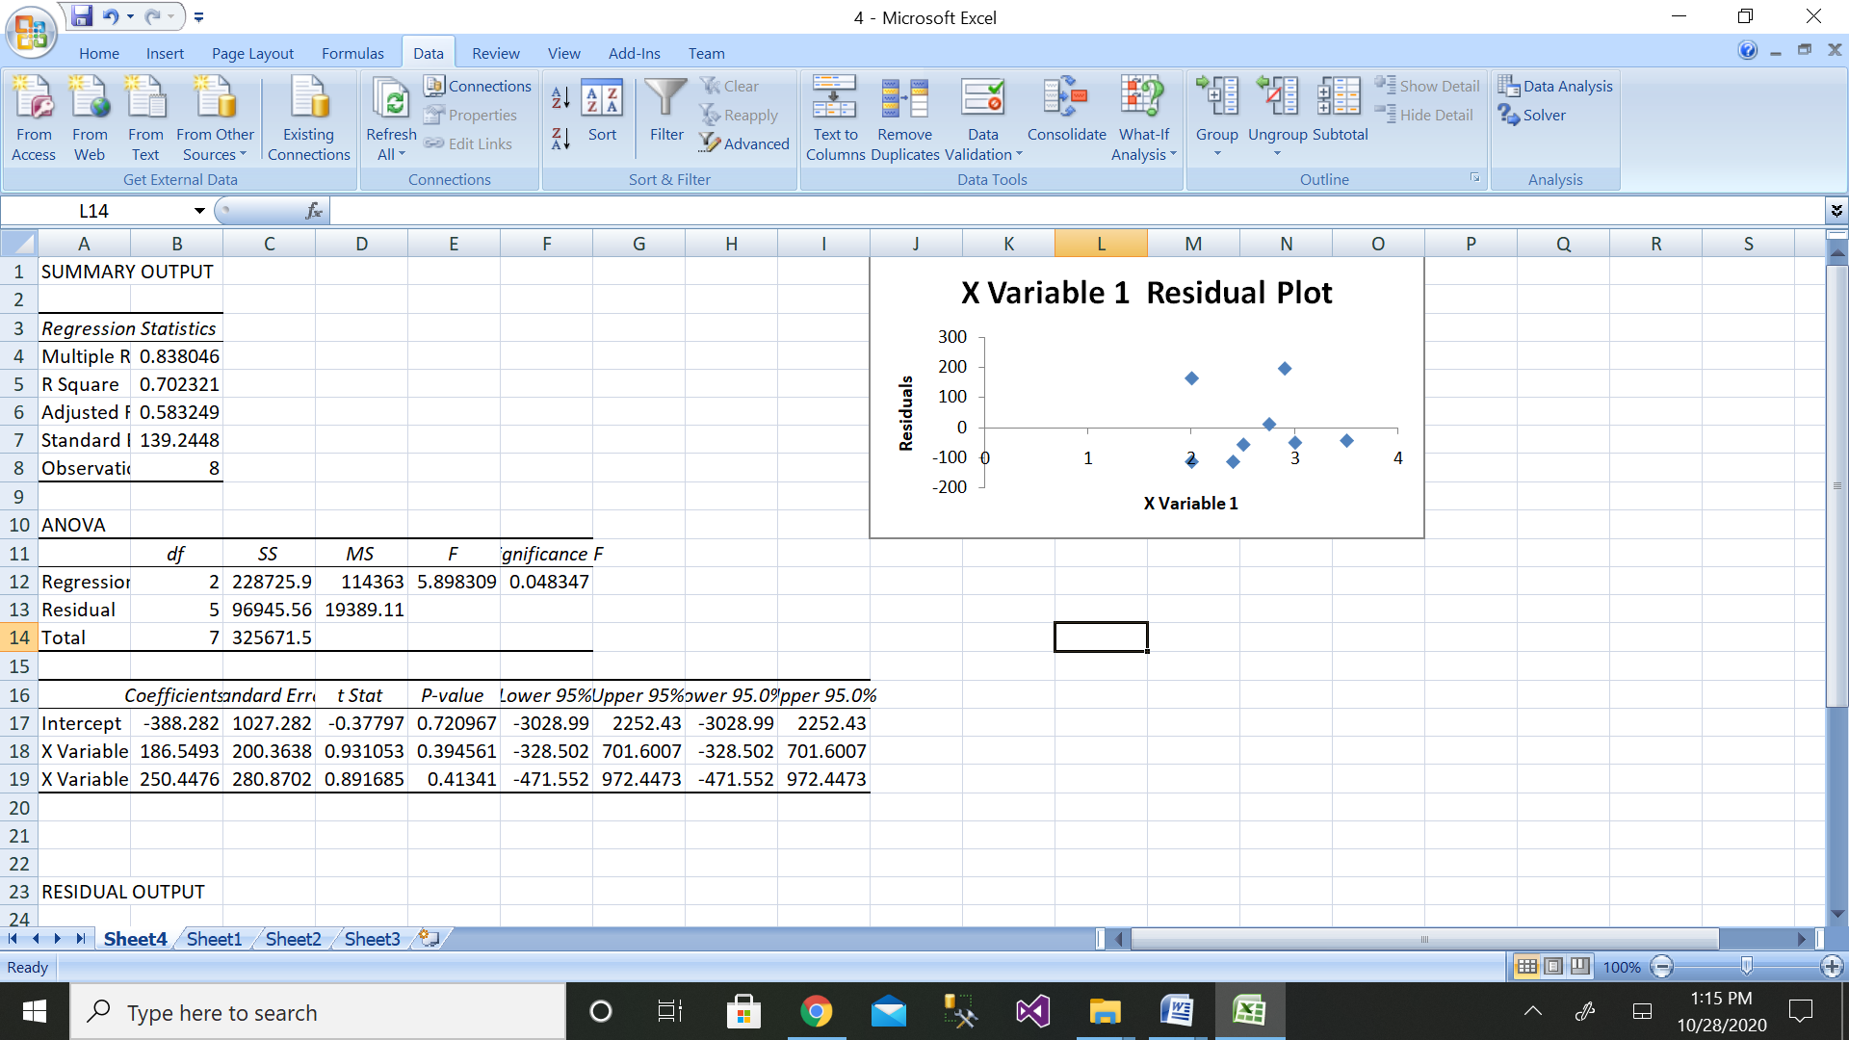

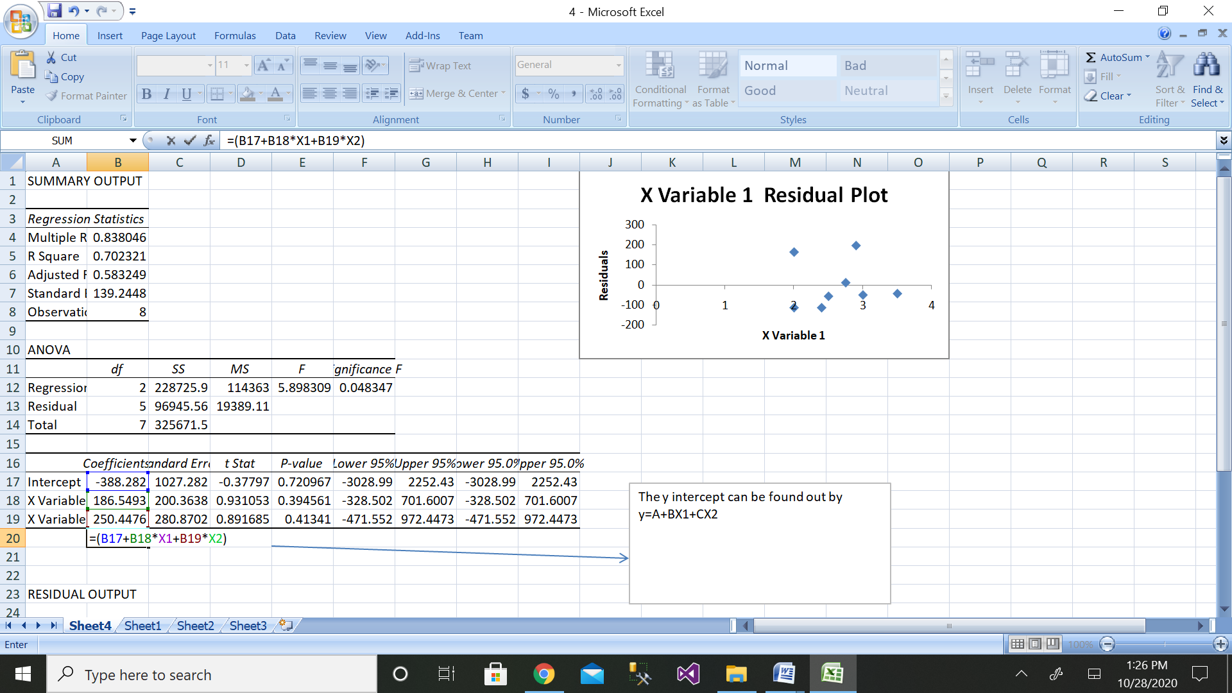

The comparison of values can be done by the above graph.

1. Calculate the total interest paid on a car loan which has been availed from HDFC bank. For example, Rs.10,00,000 has been borrowed from a bank with annual interest rate of 5.2% and the customer needs to pay every month as shown in table below. Calculate the total interest rate paid for a loan availed of Rs.10,00,000during 3 years.

|  |  |  |
| --- | --- | --- |
| Sl No. | A | B |
| 1 | Principal | Rs.10,00,000 |
| 2 | Annual interest rate | 5.20% |
| 3 | Year of the loan | 3 |
| 4 | Starting payment number | 1 |
| 5 | Ending payment number | 36 |
| 6 | total interest paid during period | ? |
|  |  |  |

One of the easiest ways to calculate the EMI on your loan is by using Microsoft Excel. Excel provides a simple formula for this purpose: PMT (rate, nper, pv, [fv], [type]).

PMT stands for Payment – and gives periodic loan payment or EMI value as an output. The arguments required for this function are:

* rate - The interest rate for the loan.
* nper - The total number of payments for the loan.
* pv - The present value, or the total value of all loan payments now, i.e. the outstanding loan amount.
* fv - [optional] The future value, or a cash balance you want after the last payment is made. Defaults to 0, i.e. the outstanding loan amount after all the payments are made.
* type - [optional] When payments are due. 0 = end of the period. 1 = beginning of the period. Default is 0.

When using this function, make sure that the units for rate and nper are the same. For example, if you are looking to calculate monthly EMI, the rate should be the monthly interest rate and not the annual interest rate. Let us look at an example to understand this:

Consider a loan of ₹10 lakh at 10% interest per annum for 20 years. If it is repaid in quarterly instalments:

Rate = 10%/4 per quarter

Npr = 20X4

EMI calculation in excel will be:

**= PMT(10%/4, 20*4, 10,00,000)**

|  |  |  |
| --- | --- | --- |
| Sl No. | A | B |
| 1 | Principal | Rs.10,00,000 |
| 2 | Annual interest rate | 5.20% |
| 3 | Year of the loan | 3 |
| 4 | Starting payment number | 1 |
| 5 | Ending payment number | 36 |
| 6 | total interest paid during period | ($90,541.68) |

1. Create a supplier database of 10 records with SUPPLIER_ID as primary key, SUPPLIER_NAME, PRODUCTS, QUANTITY, ADDRESS, CITY,PHONE_NO and PINCODE, Where SUPPLIER_NAME, PRODUCTS, QUANTITY and PHONE_NO, should not be NULL.

Solution:

mysql> create table supplier(SUPPLIER_ID varchar(20) , SUPPLIER_NAME varchar(20) not null, PRODUCTS varchar(20) not null, QUANTITY varchar(20) not null, ADDRESS varchar(20), CITY varchar(20), PHONE_NO integer(20) not null, PINCODE varchar(20), primary key(SUPPLIER_ID));

Query OK, 0 rows affected

mysql> insert into supplier values("111","amar","pen","20","peenya","bangalore",12345678,560057);

Query OK, 1 row affected (0.01 sec)

mysql> insert into supplier values("222","akbar","pencil","20","peenya","bangalore",12345678,560057);

Query OK, 1 row affected (0.01 sec)

mysql> insert into supplier values("333" ,"anthnony" ,"pencil" ,"20" ,"peenya" ,"bangalore" ,12345688 ,560057);

Query OK, 1 row affected (0.01 sec)

mysql> insert into supplier values("444","mahi","eraser","25","jharkand","bengal",12675688,650078);

Query OK, 1 row affected (0.01 sec)

mysql> insert into supplier values("555","manya","book","25","jharkand","bengal",12699988,650078);

Query OK, 1 row affected (0.01 sec)

mysql> insert into supplier values("666" ,"manyata" ,"sharpner" ,"25" ,"hebbal", "bangalore" ,99699988 ,650078);

Query OK, 1 row affected (0.01 sec)

mysql> insert into supplier values("888" ,"jennifer" ,"sharpner" ,"25" ,"hebbal" ,"bangalore" ,89699988 ,789098);

Query OK, 1 row affected (0.01 sec)

insert into supplier values("999","joyes","chart","25","agra","delhi",89688548,324098) ;

Query OK, 1 row affected (0.01 sec)

insert into supplier values("000","suchitra","pen pencil","25","agra","delhi",89666548,324099);

Query OK, 1 row affected (0.01 sec)

insert into supplier values("1111","hemcheth","choclate","25","bidadi","mandya",9654321,234199);

Query OK, 1 row affected (0.01 sec)

mysql> select * from supplier;

+-------------+---------------+------------+----------+----------+-----------+----------+---------+

| SUPPLIER_ID | SUPPLIER_NAME | PRODUCTS | QUANTITY | ADDRESS | CITY | PHONE_NO | PINCODE |

+-------------+---------------+------------+----------+----------+-----------+----------+---------+

| 000 | suchitra | pen pencil | 25 | agra | delhi | 89666548 | 324099 |

| 111 | amar | pen | 20 | peenya | bangalore | 12345678 | 560057 |

| 1111 | hemcheth | choclate | 25 | bidadi | mandya | 9654321 | 234199 |

| 222 | akbar | pencil | 20 | peenya | bangalore | 12345678 | 560057 |

| 333 | anthnony | pencil | 20 | peenya | bangalore | 12345688 | 560057 |

| 444 | mahi | eraser | 25 | jharkand | bengal | 12675688 | 650078 |

| 555 | manya | book | 25 | jharkand | bengal | 12699988 | 650078 |

| 666 | manyata | sharpner | 25 | hebbal | bangalore | 99699988 | 650078 |

| 888 | jennifer | sharpner | 25 | hebbal | bangalore | 89699988 | 789098 |

| 999 | joyes | chart | 25 | agra | delhi | 89688548 | 324098 |

+-------------+---------------+------------+----------+----------+-----------+----------+---------+

10 rows in set (0.00 sec)

1. Create the customer database of a big Market with CUSTOMER_IDas primary key,CUSTOMER_NAME, PHONE_NO, EMAIL_ID, ADDRESS, CITY and PIN_CODE. Store at least twenty customers details where CUSTOMER_NAME and PHONE_NO are mandatory and display the customer data in alphabetical order.

mysql> create table big_market(CUSTOMER_ID varchar(20), CUSTOMER_NAME varchar(20) not null, PHONE_NO integer(30) not null, EMAIL varchar(20),ADDRESS varchar(20), CITY varchar(20),PINCODE integer(20),primary key(CUSTOMER_ID));

Query OK, 0 rows affected(0.07 sec)

insert into big_market values("111","Geetha",7019231,"geetha.b@reva.edu.in","peenya", "bangalore" ,560057);

Query OK, 1 row affected (0.02 sec)

mysql> insert into big_market values("2","HEM",23719231,"hem@reva.edu.in","khalli", "bangalore",560035);

Query OK, 1 row affected (0.01 sec)

mysql> insert into big_market values("3","nagesh",23719231,"nagi@reva.edu.in","khalli", "bangalore" ,560035);

Query OK, 1 row affected (0.01 sec)

mysql> insert into big_market values("4","akki",23732731,"akki@reva.edu.in","khalli","bangalore", 560035);

Query OK, 1 row affected (0.01 sec)

mysql> insert into big_market values("5","vinay",87732731,"vinu@reva.edu.in","khalli","bangalore", 560035);

Query OK, 1 row affected (0.01 sec)

mysql> insert into big_market values("6","shankar",87732731,"shankar@reva.edu.in","khalli", "bangalore", 560035);

Query OK, 1 row affected (0.01 sec)

mysql> insert into big_market values("7","kali",56732731,"kal@reva.edu.in","dhalli", "bangalore",560067);

Query OK, 1 row affected (0.01 sec)

mysql> insert into big_market values("8","chetan",70982731,"chethu@reva.edu.in","dhalli", "bangalore",560067);

Query OK, 1 row affected (0.01 sec)

mysql> insert into big_market values("9","giri",90882731,"giri@reva.edu.in","dhalli", "bangalore",560057);

Query OK, 1 row affected (0.01 sec)

mysql> insert into big_market values("10","lat",090882731,"lat@reva.edu.in","dhalli", "bangalore",560057);

Query OK, 1 row affected (0.01 sec)

mysql> insert into big_market values("11","gowrish",99882731,"gowri@reva.edu.in","dhalli", "bangalore",560057);

Query OK, 1 row affected (0.01 sec)

mysql> insert into big_market values("12","suri",99882731,"suri@reva.edu.in","dhalli", "bangalore",560057);

Query OK, 1 row affected (0.01 sec)

mysql> insert into big_market values("13","kat",99800831,"kat@reva.edu.in","dhalli", "bangalore",560057);

Query OK, 1 row affected (0.01 sec)

mysql> insert into big_market values("14","shalini",99776831,"shalini@reva.edu.in","mhalli", "bangalore",560057);

Query OK, 1 row affected (0.01 sec)

mysql> insert into big_market values("15","thiru",900776831,"thiru@reva.edu.in","mhalli", "bangalore",560057);

Query OK, 1 row affected (0.01 sec)

mysql> insert into big_market values("16","archana",987776831,"archana@reva.edu.in","hennu", "bangalore",560407);

Query OK, 1 row affected (0.01 sec)

mysql> insert into big_market values("17","anirudh",886776831,"ani@reva.edu.in","hennu", "bangalore",560407);

Query OK, 1 row affected (0.01 sec)

mysql> insert into big_market values("18","aman",776776831,"aman@reva.edu.in","kannur", "bangalore",509907);

Query OK, 1 row affected (0.01 sec)

mysql> insert into big_market values("19","akash",776776831,"akash@reva.edu.in","kannur" ,"bangalore", 509907);

Query OK, 1 row affected (0.01 sec)

mysql> insert into big_market values("20","santosh",776776831,"sant@reva.edu.in","kannur", "bangalore" , 509907);

Query OK, 1 row affected (0.01 sec)

mysql> select * from big_market;

+-------------+---------------+-----------+----------------------+---------+-----------+---------+

| CUSTOMER_ID | CUSTOMER_NAME | PHONE_NO | EMAIL | ADDRESS | CITY | PINCODE |

+-------------+---------------+-----------+----------------------+---------+-----------+---------+

| 10 | lat | 90882731 | lat@reva.edu.in | dhalli | bangalore | 560057 |

| 11 | gowrish | 99882731 | gowri@reva.edu.in | dhalli | bangalore | 560057 |

| 111 | Geetha | 7019231 | geetha.b@reva.edu.in | peenya | bangalore | 560057 |

| 12 | suri | 99882731 | suri@reva.edu.in | dhalli | bangalore | 560057 |

| 13 | kat | 99800831 | kat@reva.edu.in | dhalli | bangalore | 560057 |

| 14 | shalini | 99776831 | shalini@reva.edu.in | mhalli | bangalore | 560057 |

| 15 | thiru | 900776831 | thiru@reva.edu.in | mhalli | bangalore | 560057 |

| 16 | archana | 987776831 | archana@reva.edu.in | hennu | bangalore | 560407 |

| 17 | anirudh | 886776831 | ani@reva.edu.in | hennu | bangalore | 560407 |

| 18 | aman | 776776831 | aman@reva.edu.in | kannur | bangalore | 509907 |

| 19 | akash | 776776831 | akash@reva.edu.in | kannur | bangalore | 509907 |

| 2 | HEM | 23719231 | hem@reva.edu.in | khalli | bangalore | 560035 |

| 20 | santosh | 776776831 | sant@reva.edu.in | kannur | bangalore | 509907 |

| 3 | nagesh | 23719231 | nagi@reva.edu.in | khalli | bangalore | 560035 |

| 4 | akki | 23732731 | akki@reva.edu.in | khalli | bangalore | 560035 |

| 5 | vinay | 87732731 | vinu@reva.edu.in | khalli | bangalore | 560035 |

| 6 | shankar | 87732731 | shankar@reva.edu.in | khalli | bangalore | 560035 |

| 7 | kali | 56732731 | kal@reva.edu.in | dhalli | bangalore | 560067 |

| 8 | chetan | 70982731 | chethu@reva.edu.in | dhalli | bangalore | 560067 |

| 9 | giri | 90882731 | giri@reva.edu.in | dhalli | bangalore | 560057 |

+-------------+---------------+-----------+----------------------+---------+-----------+---------+

20 rows in set (0.00 sec)

To arrange in alphabetical order;

mysql> select * from big_market order by CUSTOMER_NAME;

+-------------+---------------+-----------+----------------------+---------+-----------+---------+

| CUSTOMER_ID | CUSTOMER_NAME | PHONE_NO | EMAIL | ADDRESS | CITY | PINCODE |

+-------------+---------------+-----------+----------------------+---------+-----------+---------+

| 19 | akash | 776776831 | akash@reva.edu.in | kannur | bangalore | 509907 |

| 4 | akki | 23732731 | akki@reva.edu.in | khalli | bangalore | 560035 |

| 18 | aman | 776776831 | aman@reva.edu.in | kannur | bangalore | 509907 |

| 17 | anirudh | 886776831 | ani@reva.edu.in | hennu | bangalore | 560407 |

| 16 | archana | 987776831 | archana@reva.edu.in | hennu | bangalore | 560407 |

| 8 | chetan | 70982731 | chethu@reva.edu.in | dhalli | bangalore | 560067 |

| 111 | Geetha | 7019231 | geetha.b@reva.edu.in | peenya | bangalore | 560057 |

| 9 | giri | 90882731 | giri@reva.edu.in | dhalli | bangalore | 560057 |

| 11 | gowrish | 99882731 | gowri@reva.edu.in | dhalli | bangalore | 560057 |

| 2 | HEM | 23719231 | hem@reva.edu.in | khalli | bangalore | 560035 |

| 7 | kali | 56732731 | kal@reva.edu.in | dhalli | bangalore | 560067 |

| 13 | kat | 99800831 | kat@reva.edu.in | dhalli | bangalore | 560057 |

| 10 | lat | 90882731 | lat@reva.edu.in | dhalli | bangalore | 560057 |

| 3 | nagesh | 23719231 | nagi@reva.edu.in | khalli | bangalore | 560035 |

| 20 | santosh | 776776831 | sant@reva.edu.in | kannur | bangalore | 509907 |

| 14 | shalini | 99776831 | shalini@reva.edu.in | mhalli | bangalore | 560057 |

| 6 | shankar | 87732731 | shankar@reva.edu.in | khalli | bangalore | 560035 |

| 12 | suri | 99882731 | suri@reva.edu.in | dhalli | bangalore | 560057 |

| 15 | thiru | 900776831 | thiru@reva.edu.in | mhalli | bangalore | 560057 |

| 5 | vinay | 87732731 | vinu@reva.edu.in | khalli | bangalore | 560035 |

+-------------+---------------+-----------+----------------------+---------+-----------+---------+

20 rows in set (0.01 sec)

1. Apply linear regression to find the weather (temperature) of a city with the amount of rain in centimeters. Create your own database with following details.

|  |  |  |
| --- | --- | --- |
| CITY | Temperature in Centigrade | Rain in Centimeters |
|  |  |  |

Solution:

Step 1: Height data have been taken from dataset.

|  |  |
| --- | --- |
| Temperature in centigrade | Rain in centimeters |
| 23 | 163 |
| 25 | 158 |
| 22 | 167 |
| 18 | 170 |
| 20 | 160 |
| 15 | 180 |
| 16 | 175 |
| 17 | 172 |

Step 2: Enter the data for Independent Variable x and dependent variable y as shown above 11 values

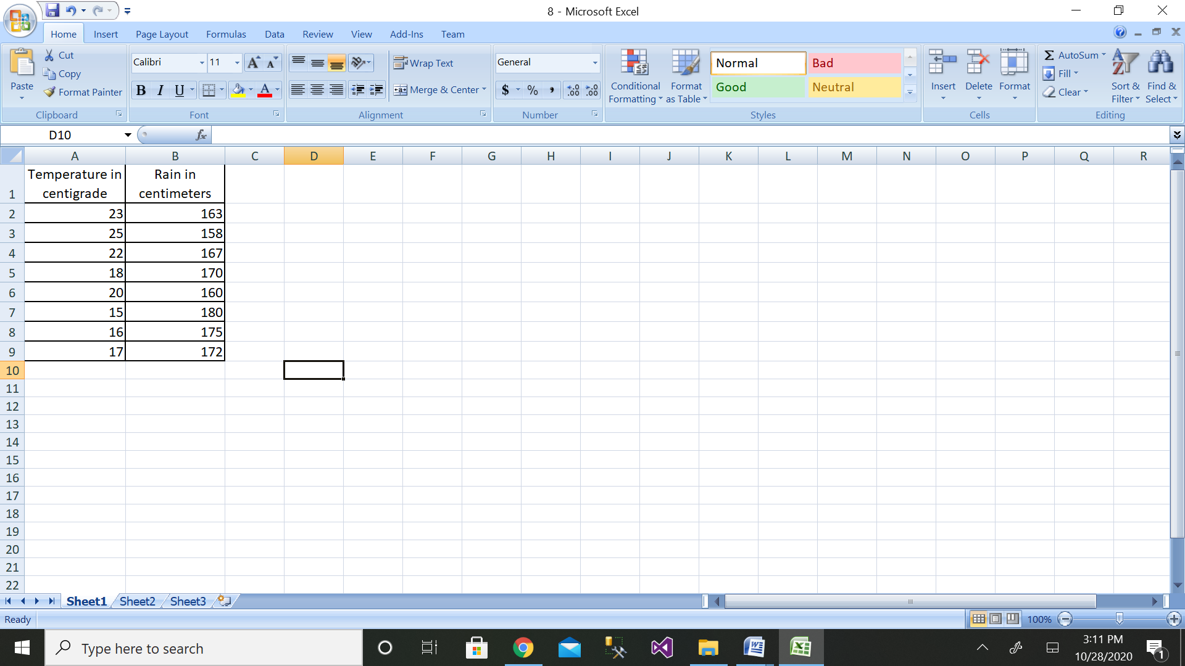

Step 3: Then click on the Data Analysis button

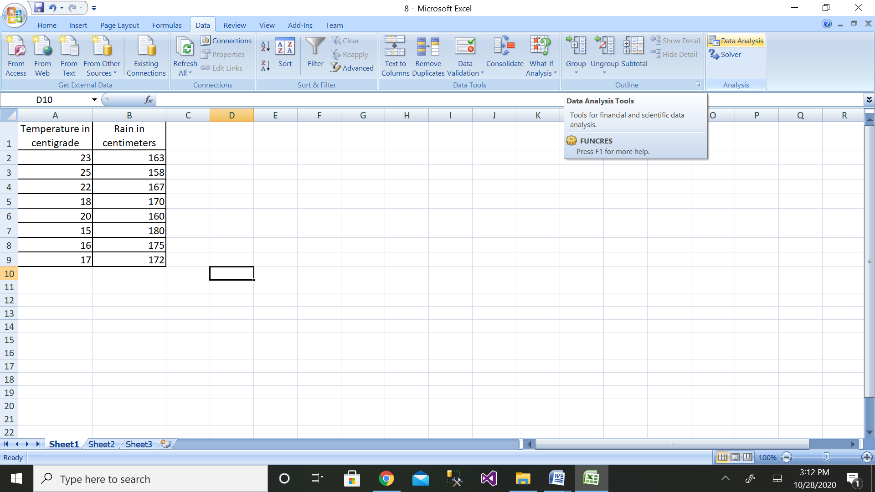

Step 4: Then click on the Regression button

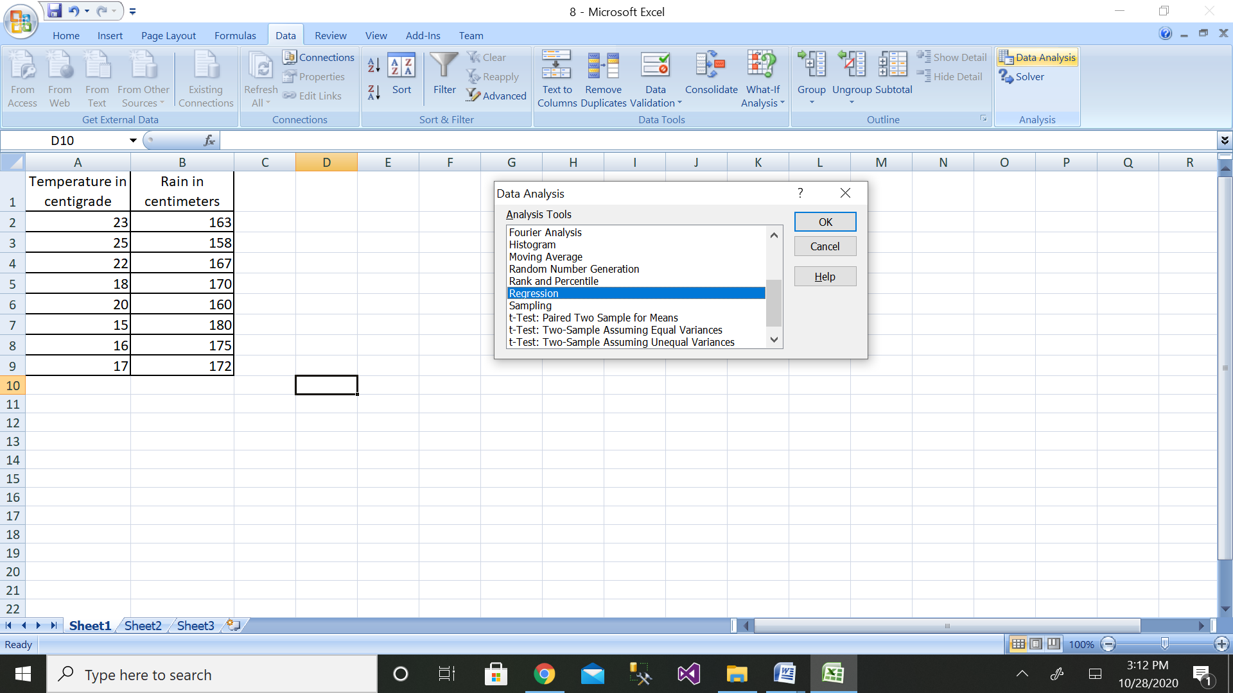

Step 5: Then select the range of dependent variable as shown above

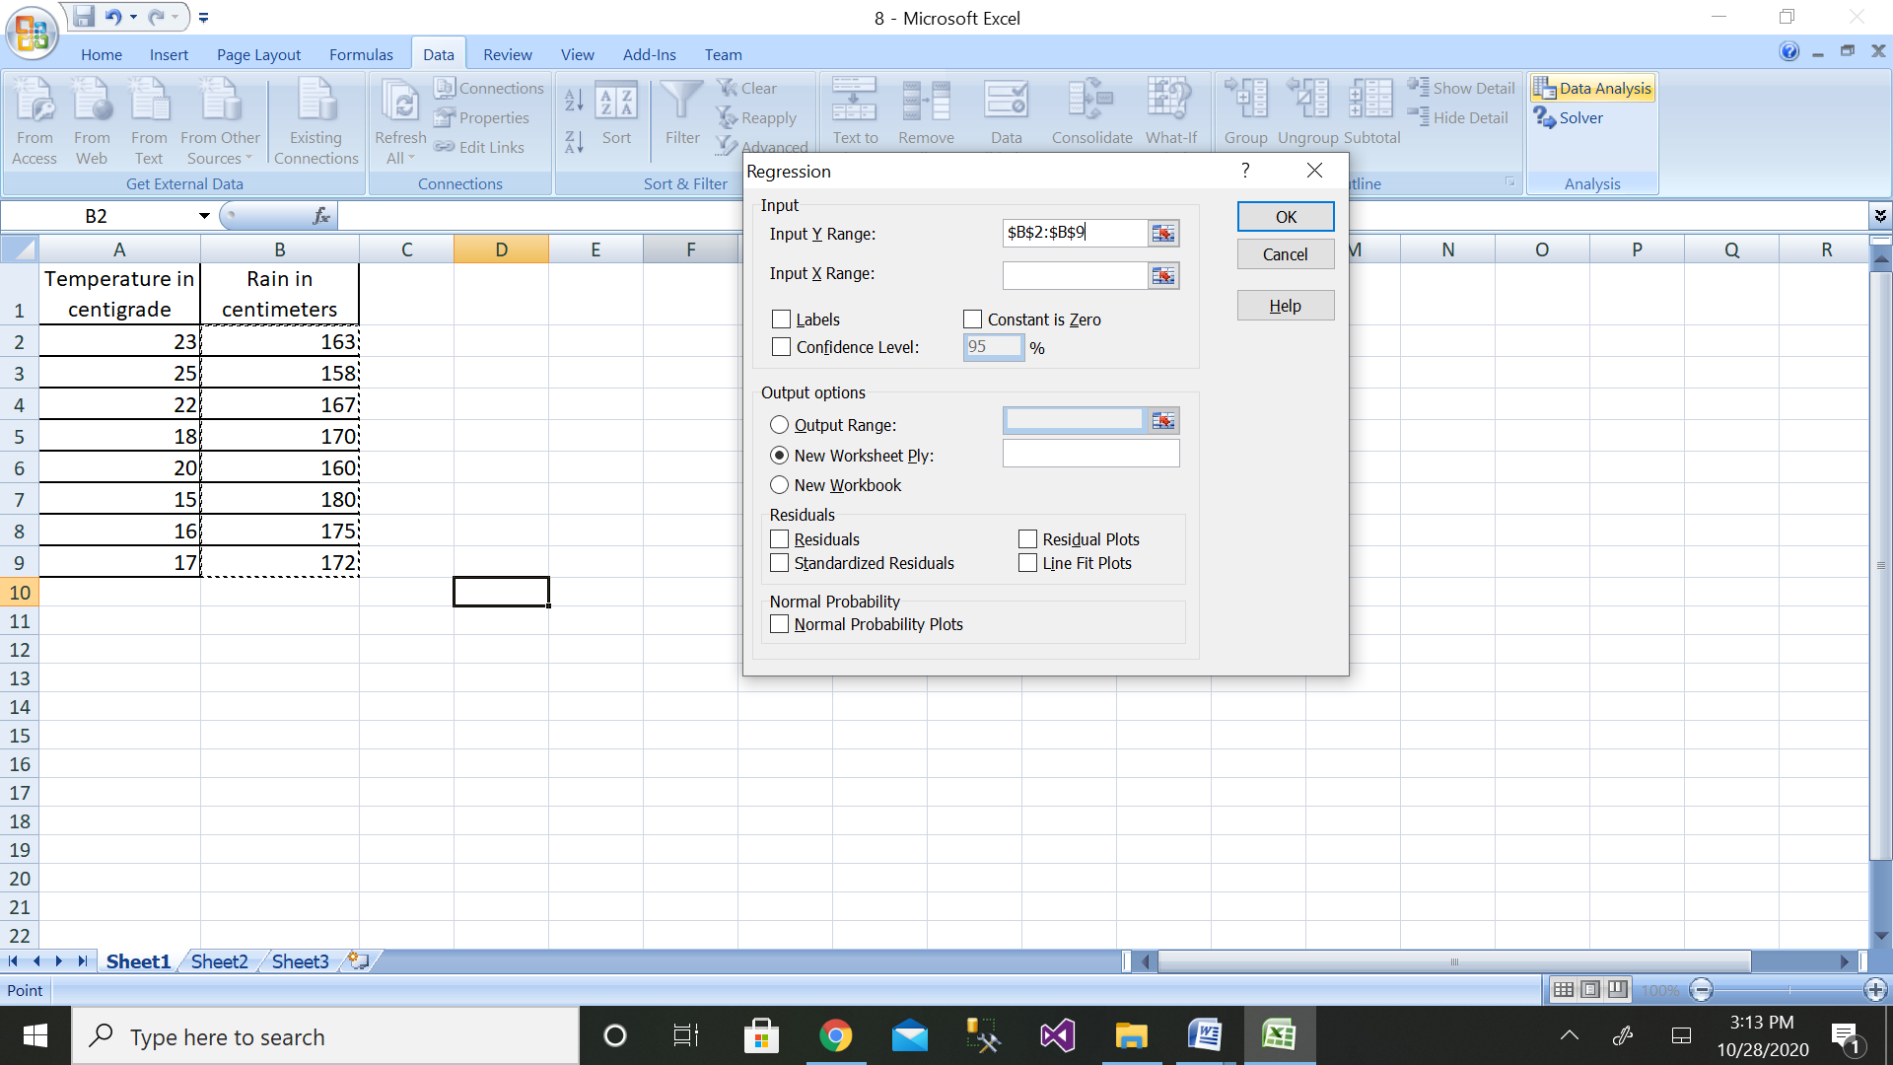

Step 6: After selecting both ranges click on ok button

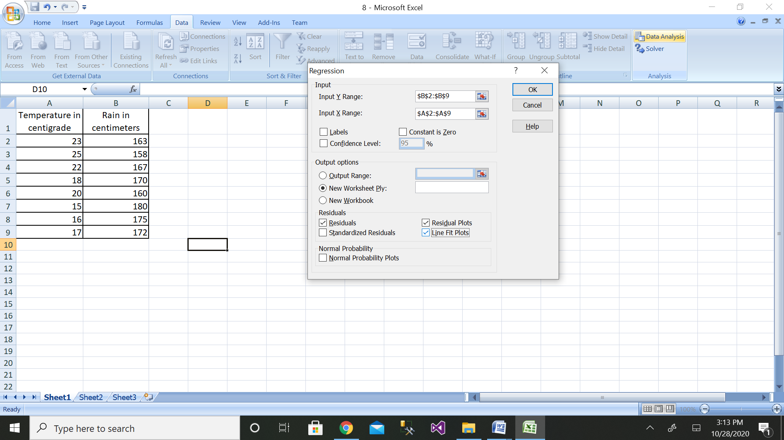

Step 7: We will get the output as shown with residual plot graph

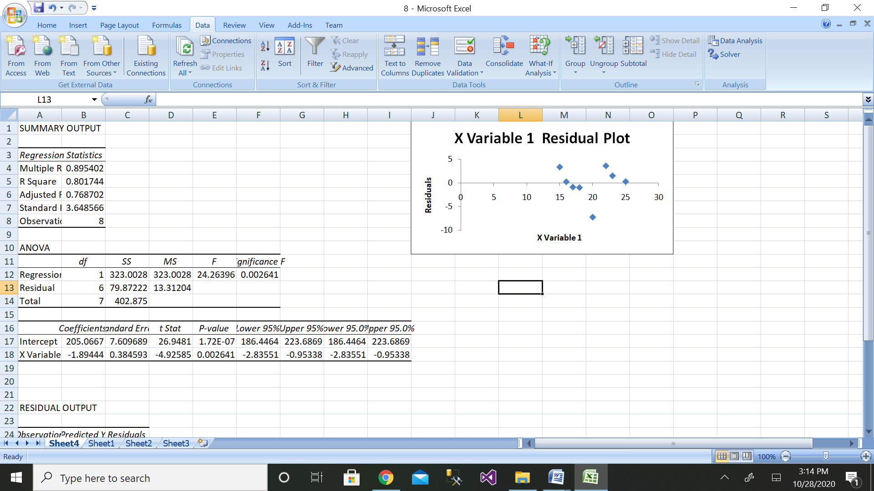

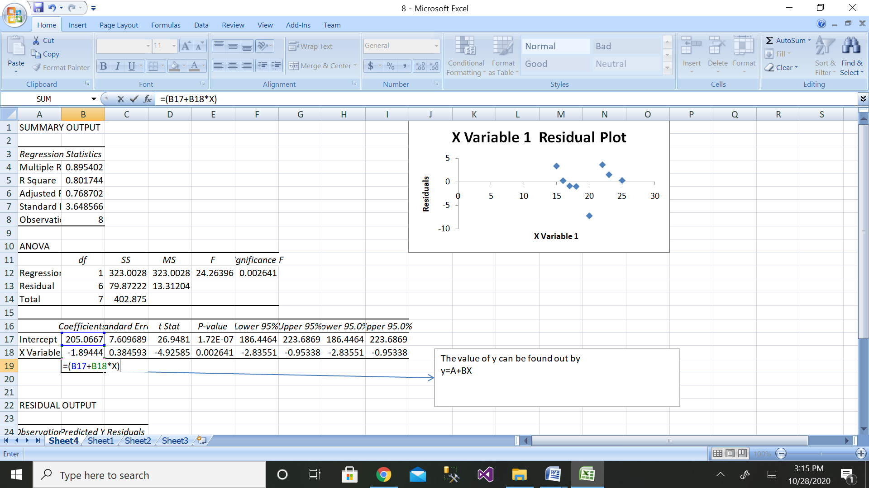

The comparison of values can be done by the above graph.

9. Use the linear regression technique to compare the age of humans with the amount of sleep in hours.

|  |  |  |
| --- | --- | --- |
| Name | Age in Years | Sleep in hours |

Create your own database with above details.

Solution:

Step 1: Height data have been taken from dataset.

|  |  |  |
| --- | --- | --- |
| Name | Age in Years | Sleep in hours |
| Ashwini | 50 | 5 |
| Arthi | 25 | 11 |
| Afreen | 29 | 9 |
| Aman | 18 | 10 |
| Hem | 10 | 13 |
| Chetan | 9 | 14 |
| Gouri | 60 | 4 |
| Ameen | 17 | 12 |

Step 2: Enter the data for Independent Variable x and dependent variable y as shown above 11 values

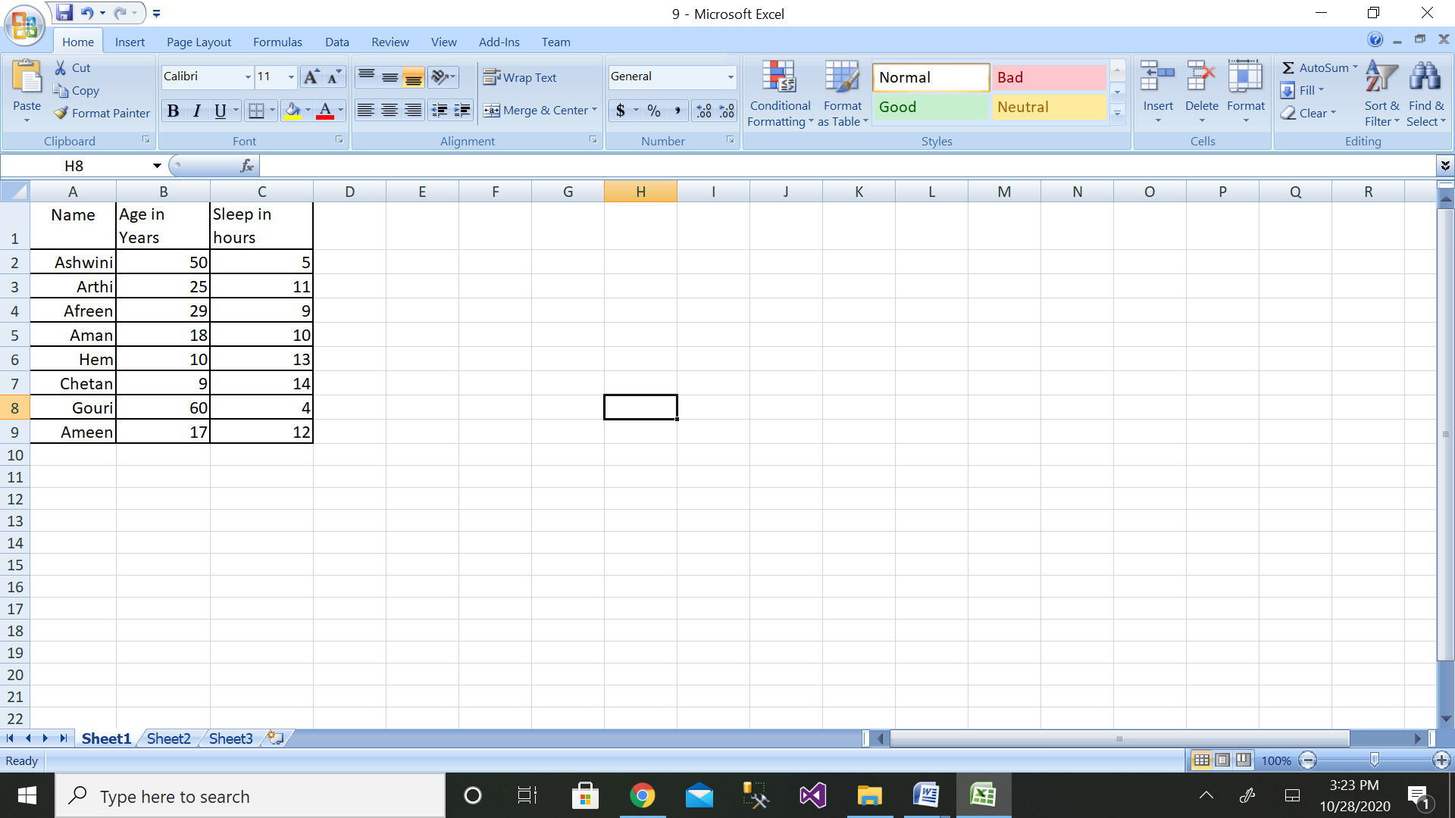

Step 3: Then click on the Data Analysis button

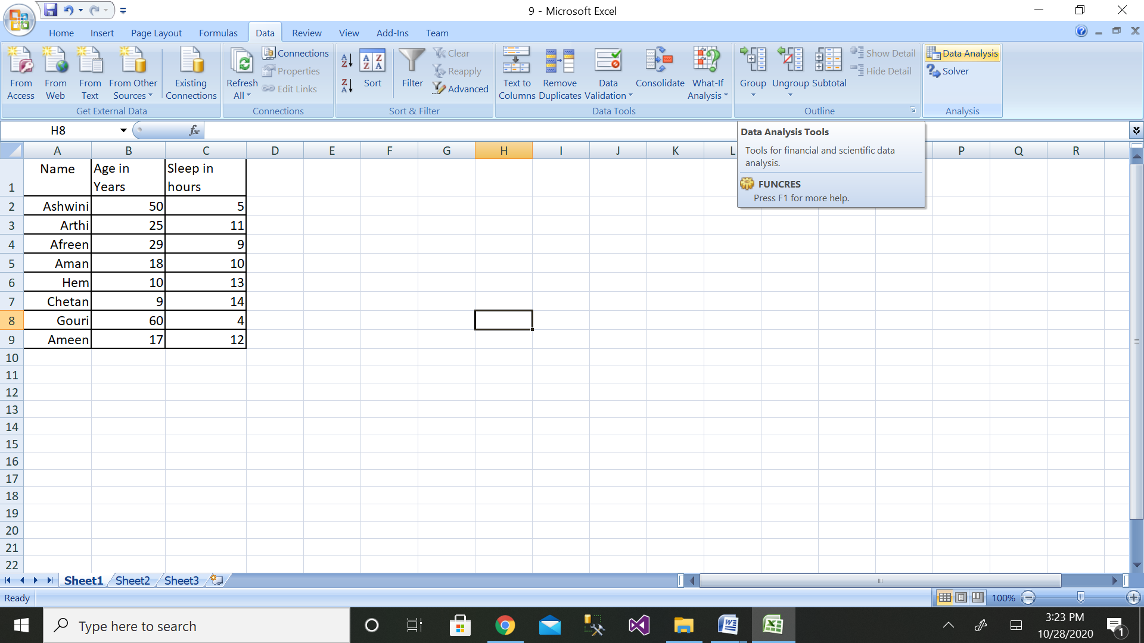

Step 4: Then click on the Regression button

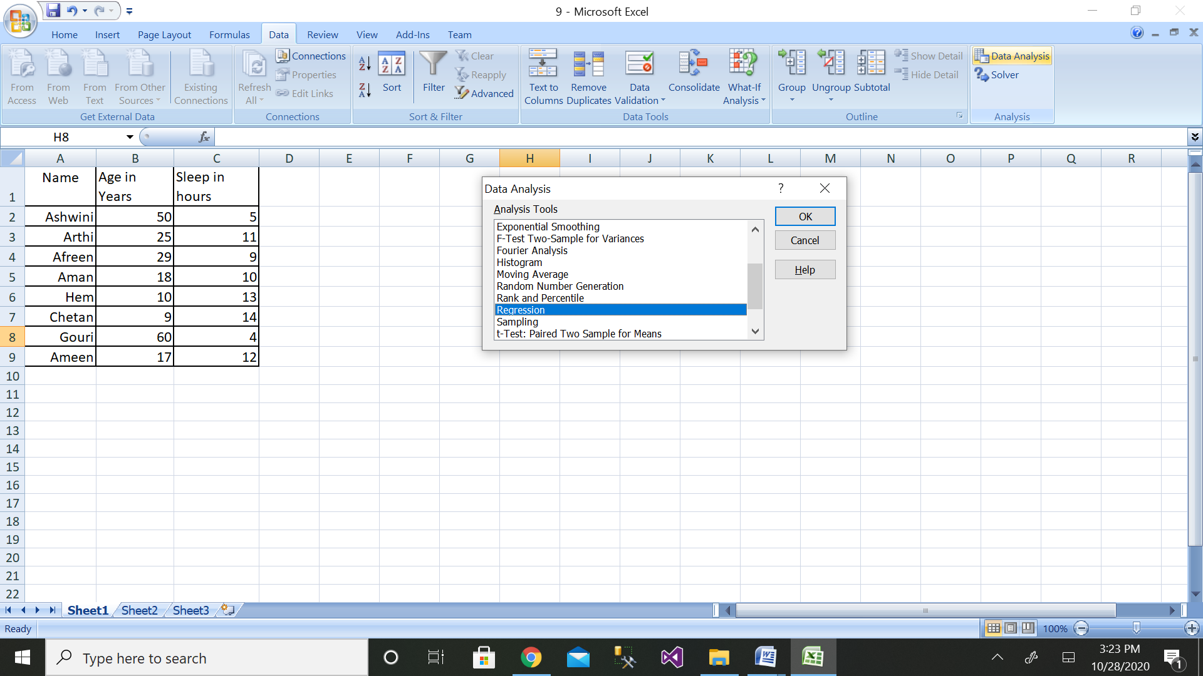

Step 5: Then select the range of dependent variable as shown above

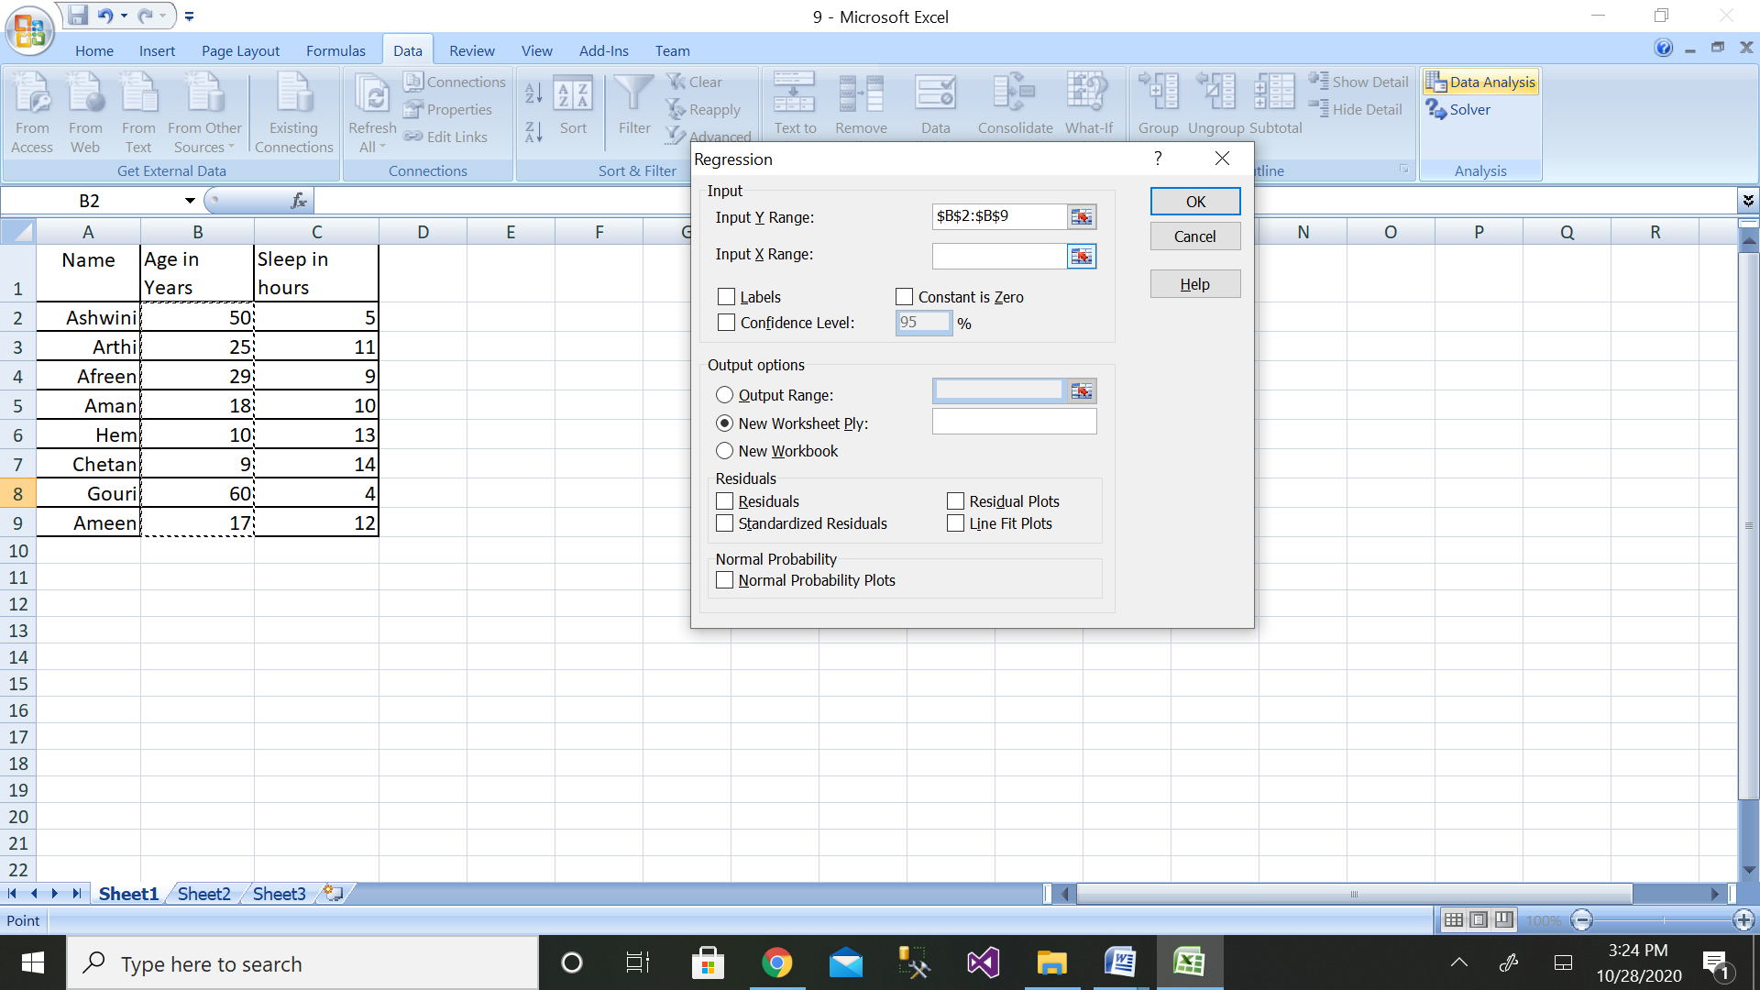

Step 6: After selecting both ranges click on ok button

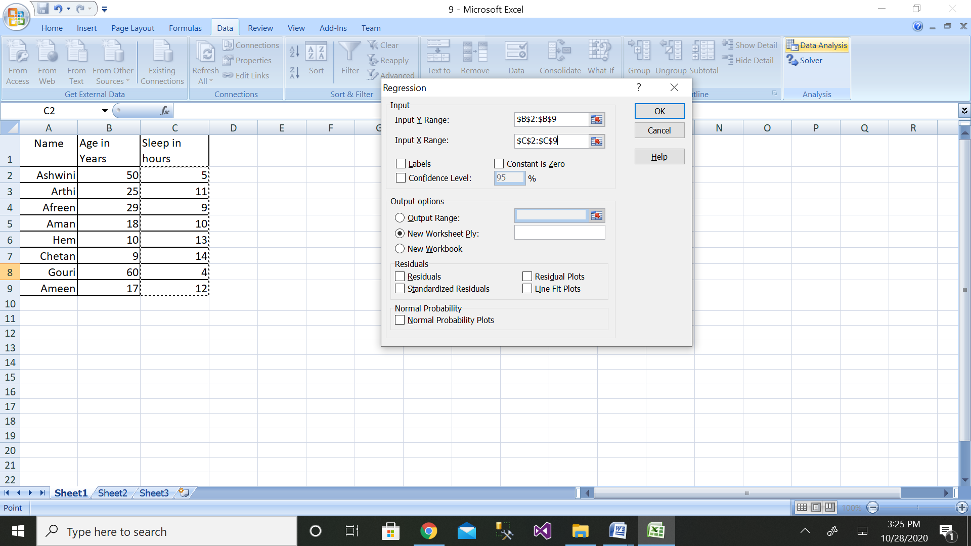

Step 7: We will get the output as shown with residual plot graph

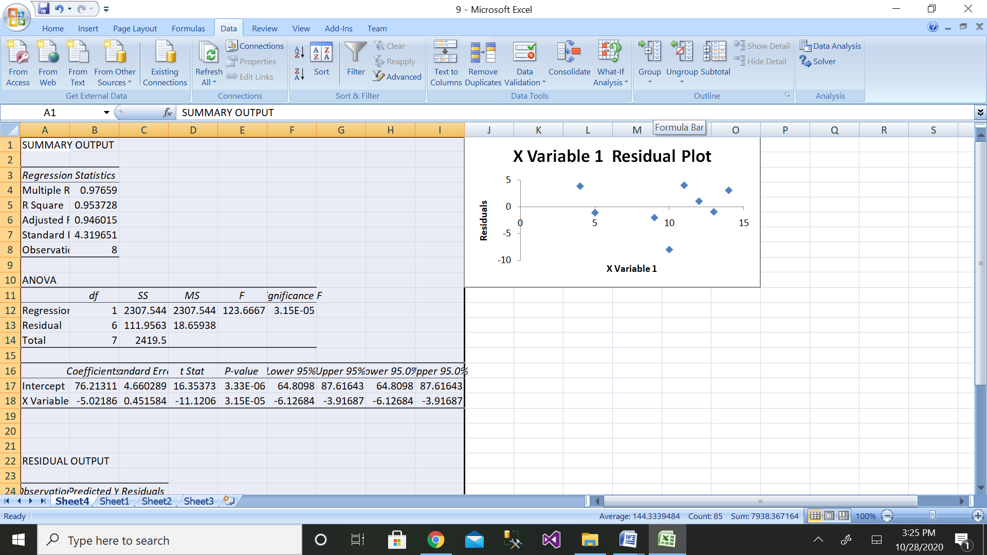

The comparison of values can be done by the above graph.

10. Apply the linear regression, compare the average salaries of batsman depending on the run rate scored/ recorded in the matches. Assume your own database.

Solution:

Step 1: Salary data have been taken from dataset.

|  |  |  |
| --- | --- | --- |
| Name | Run scored | Salary |
| Ashwini | 2000 | 50000 |
| Arthi | 1000 | 25000 |
| Afreen | 500 | 12500 |
| Aman | 2500 | 65000 |
| Hem | 3000 | 80000 |
| Chetan | 3500 | 90000 |
| Gouri | 1500 | 30000 |
| Ameen | 100 | 10000 |

Step 2: Enter the data for Independent Variable x and dependent variable y as shown above 11 values

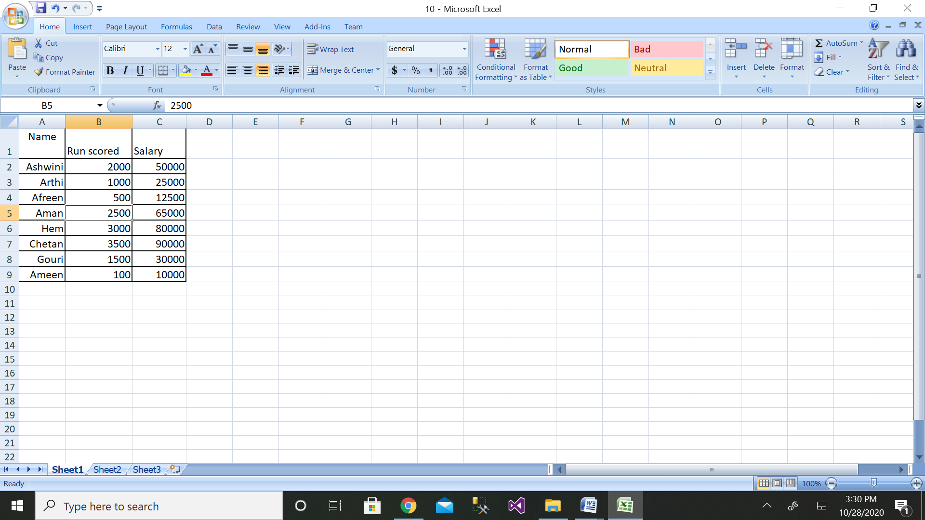

Step 3: Then click on the Data Analysis button

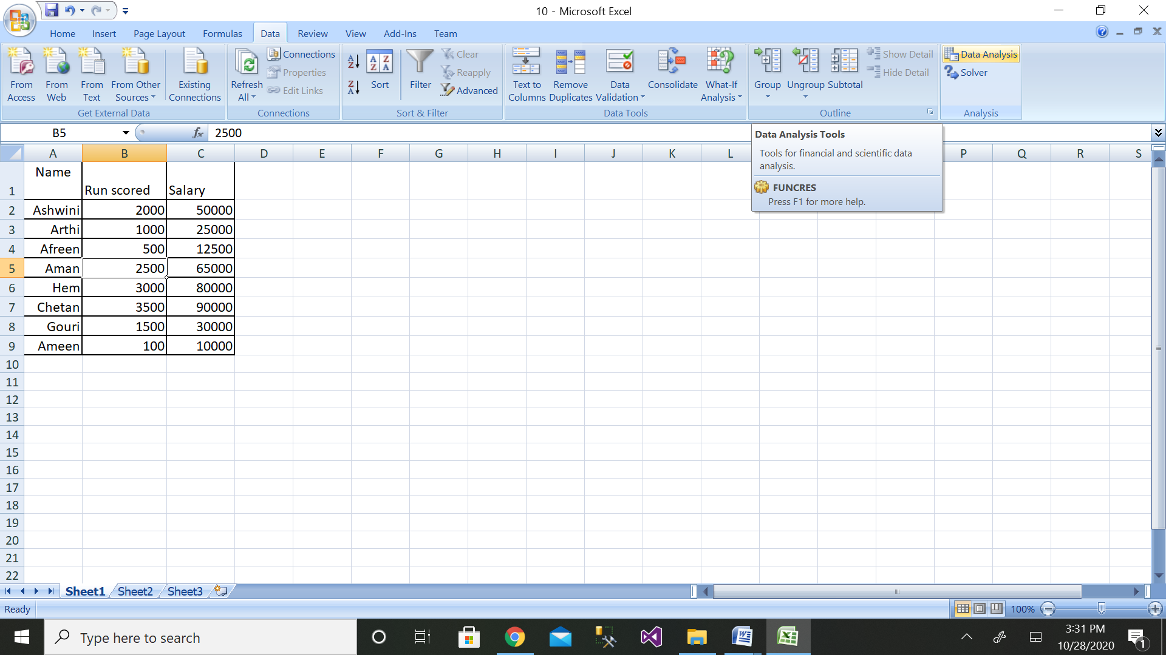

Step 4: Then click on the Regression button

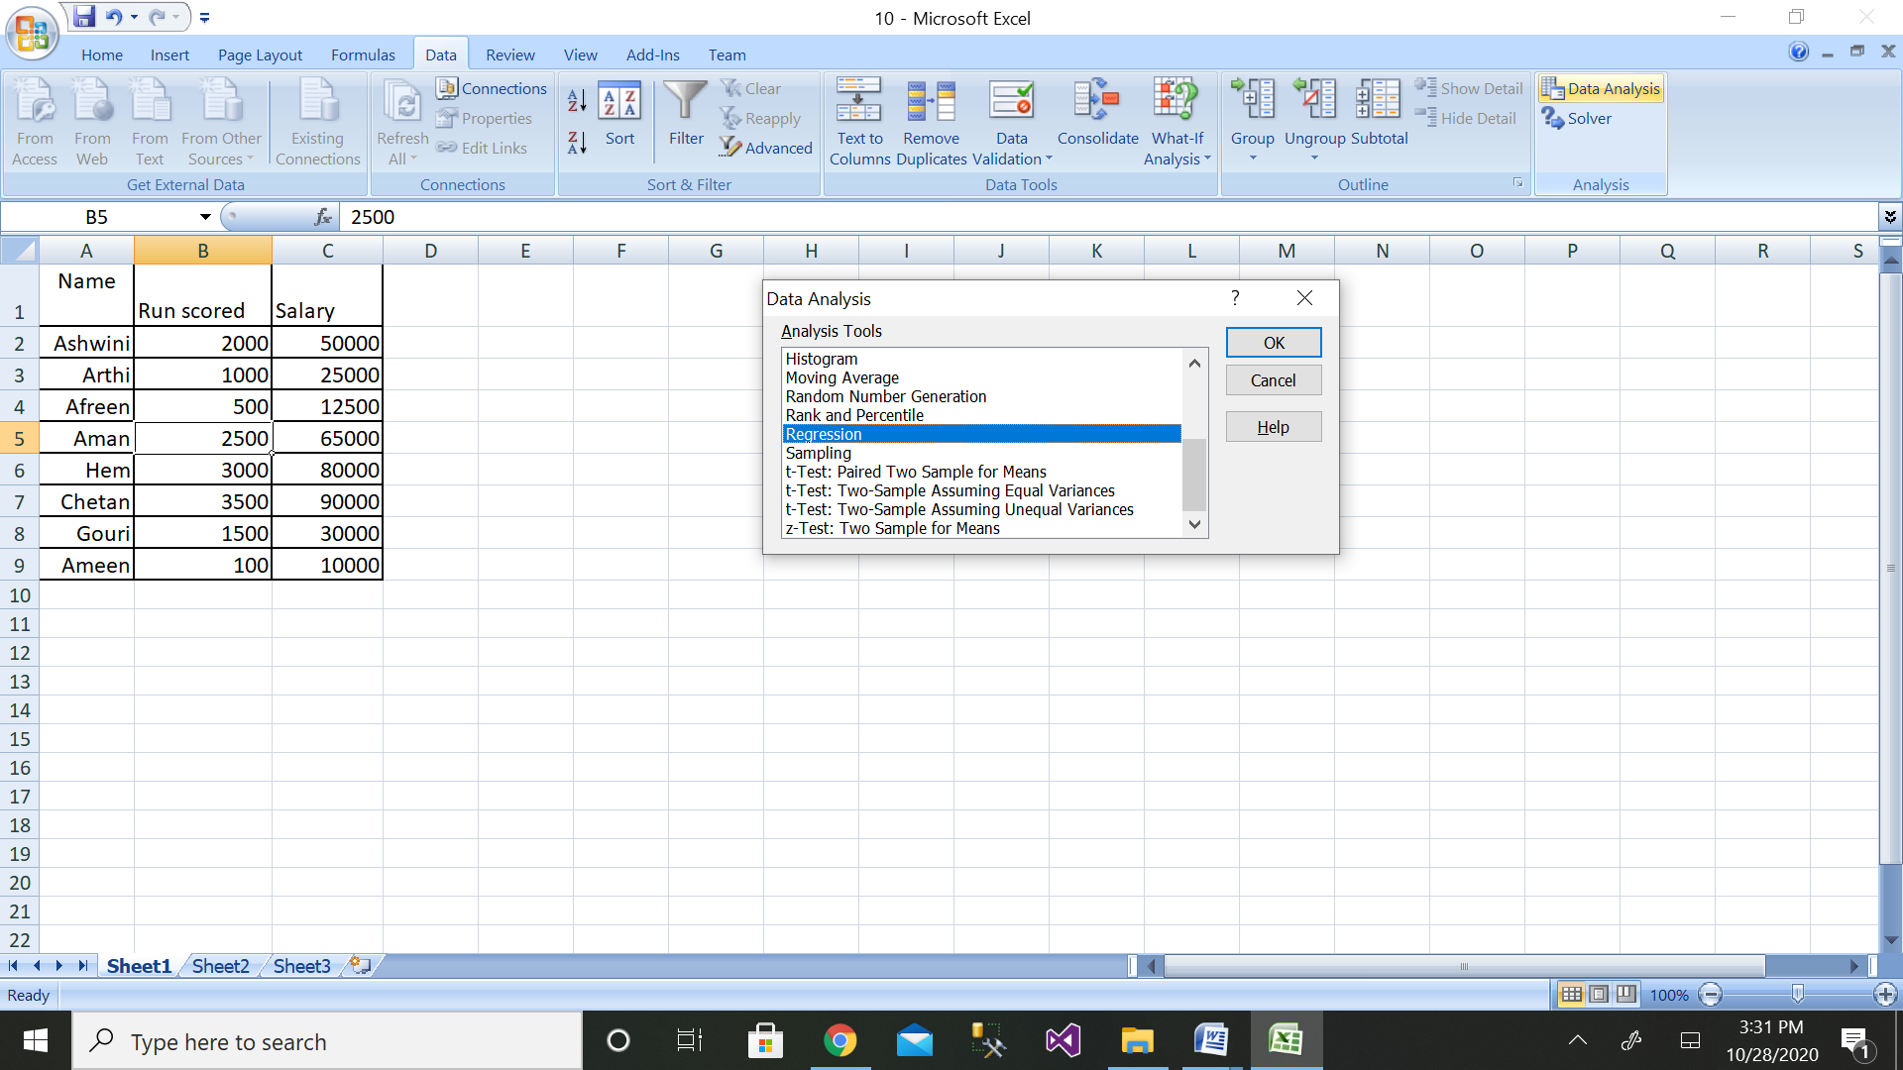

Step 5: Then select the range of dependent variable as shown above

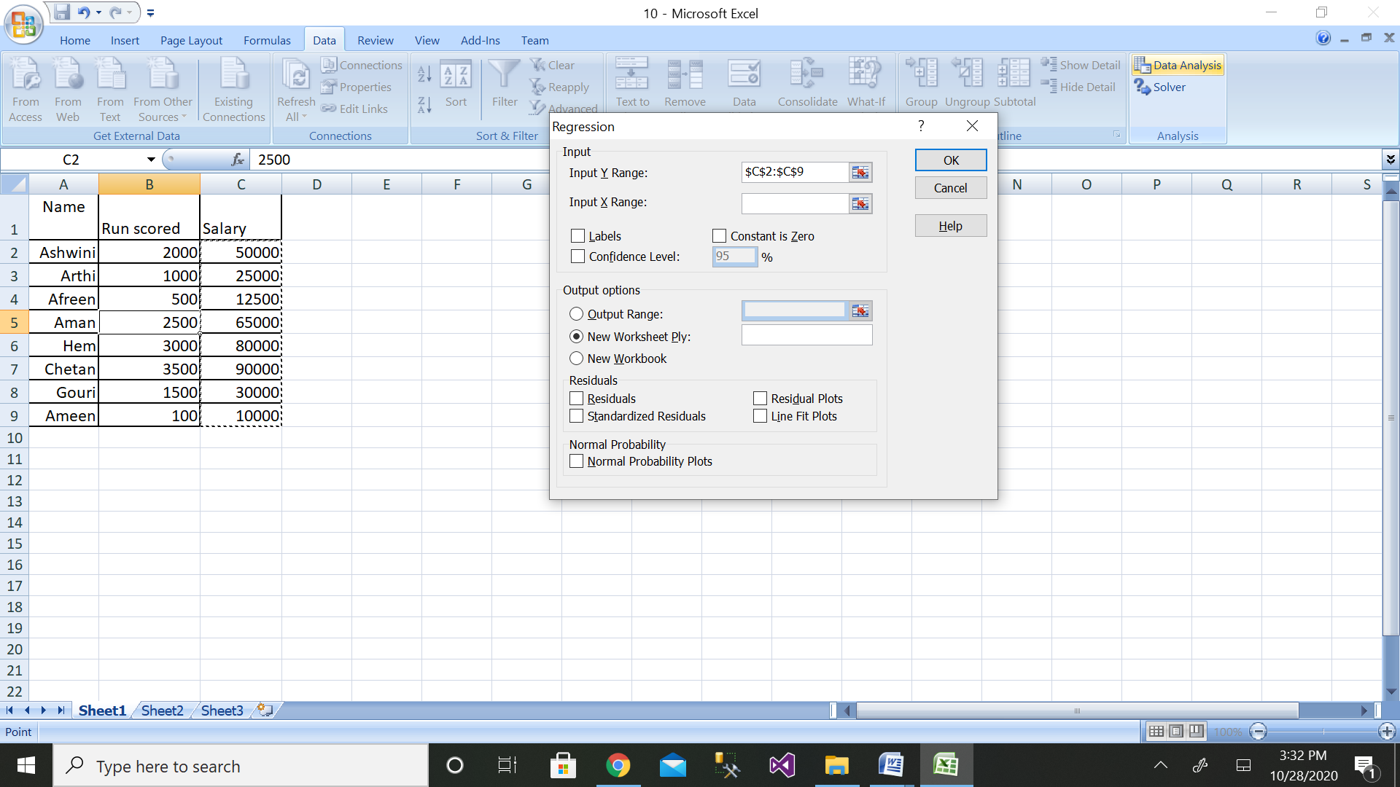

Step 6: After selecting both ranges click on ok button

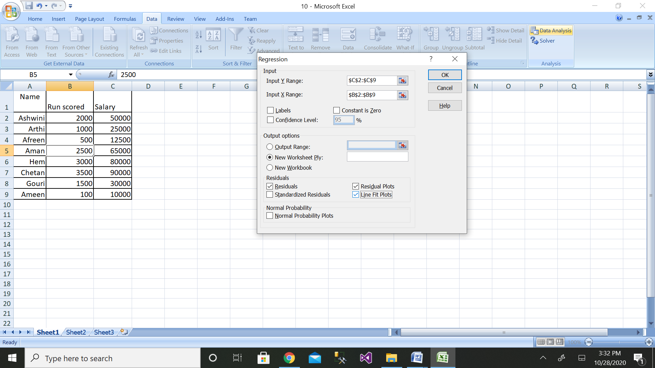

Step 7: We will get the output as shown with residual plot graph

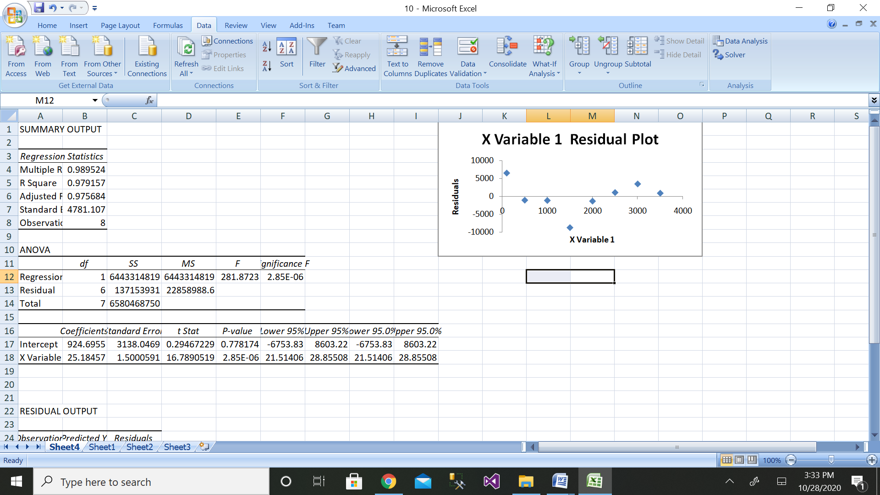

The comparison of values can be done by the above graph.

11. Design the ER diagram and create schema of the REVA library management system.

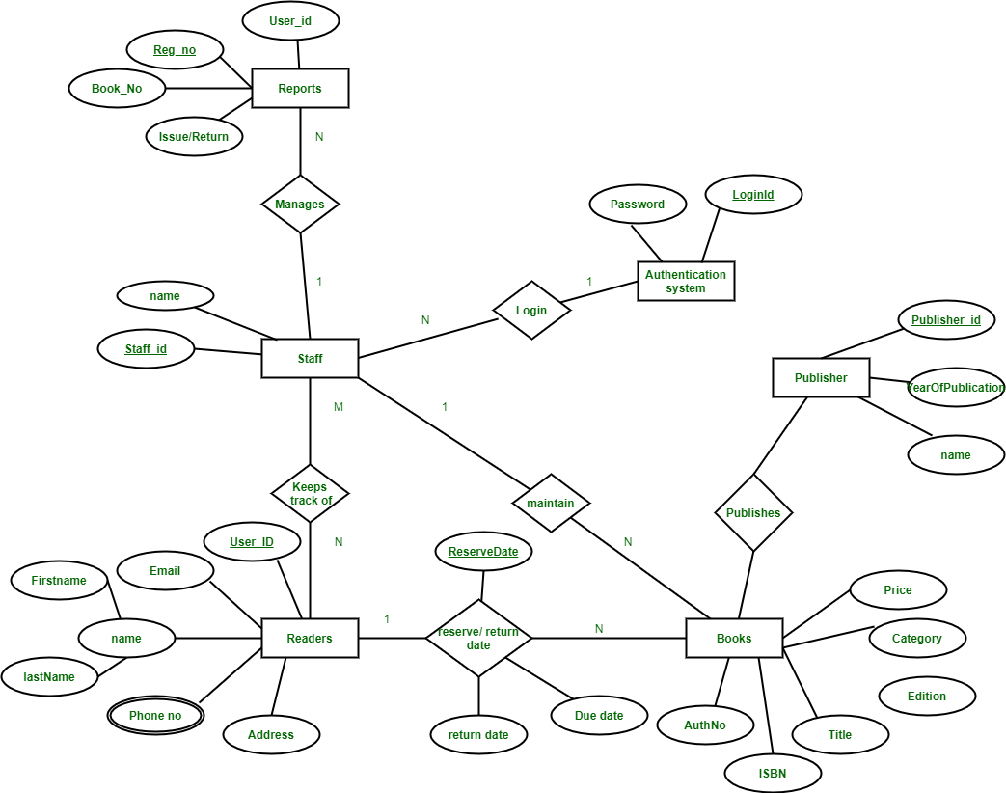

|  |  |
| --- | --- |
| Staff | |
| Name | Staff_id |

|  |  |  |  |  |
| --- | --- | --- | --- | --- |
| Readers | | | | |
| User_id | Name | Phone no | Email | Address |

|  |  |  |  |  |  |
| --- | --- | --- | --- | --- | --- |
| Books | | | | | |
| ISBN | Category | AuthNo | Title | Edition | Price |

|  |  |
| --- | --- |
| Authentication_System | |
| Login_id | Password |

|  |  |  |
| --- | --- | --- |
| Publisher | | |
| Publisher_id | Name | Year of publication |

|  |  |  |  |
| --- | --- | --- | --- |
| Reports | | | |
| User_id | Register_no | Book_no | Issue/Return |

12. Design the ER diagram and create schema for Hospital Management system.

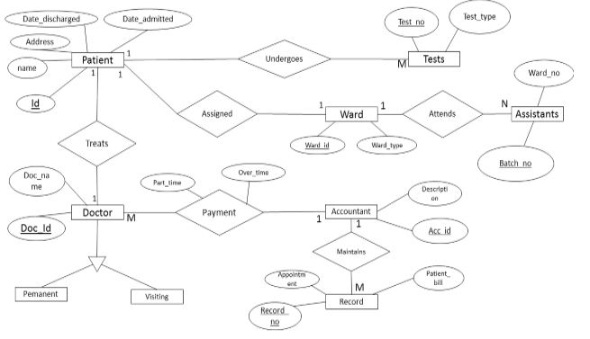

Patient

|  |  |  |  |  |
| --- | --- | --- | --- | --- |
| Id | Name | Address | Date_admitted | Date_discharged |

Doctor

|  |  |
| --- | --- |
| Doc_id | Doc_name |

Record

|  |  |  |
| --- | --- | --- |
| Record_no | Appointment | Patient_bill |

Assistant

|  |  |
| --- | --- |
| Batch_no | Ward_no |

Test

|  |  |
| --- | --- |
| Test_no | Test_type |

Account

|  |  |
| --- | --- |
| Acc_id | Description |